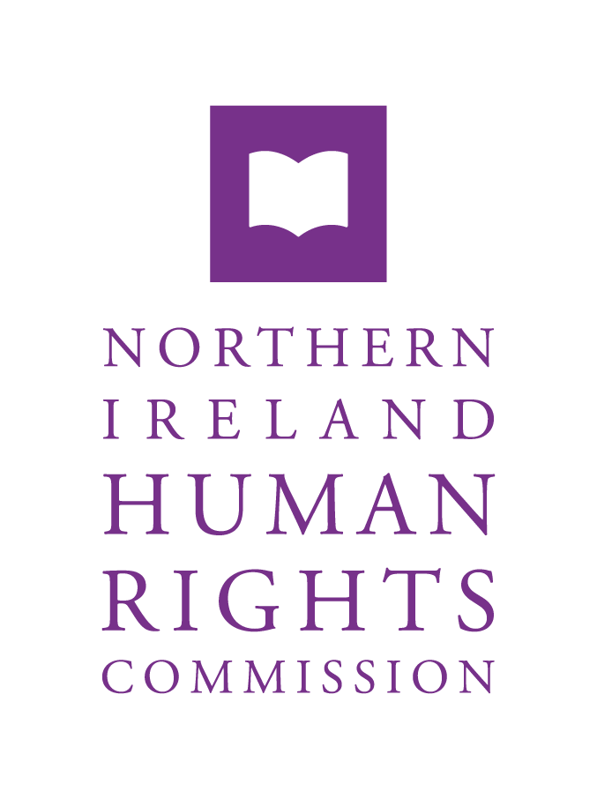
Data Protection Complaints Process

Version No: | 1.0
Version Issue Date: | 2 July 2026
Supersedes Version: | Not applicable
Approved by | Chief Executive
Created Date | July 2026
Last Review | Not applicable
Next Review | March 2027
Plan Owner | Director (Finance, Personnel and Corporate Affairs)

Version Control | Date and details of change
Version 1 | New Data Protection Complaints Process developed

How to Make a Complaint
If you have a complaint about how your data has been handled, please contact the Data Protection Officer (DPO). This allows us to investigate and resolve the issue as quickly as possible.
Email: Info@nihrc.org marked for the attention of the Data Protection Officer
When you contact us, please provide as much detail as possible about your complaint. This will help us to understand the issue and investigate it thoroughly.

What to Expect from Us
We will acknowledge receipt of your complaint within three working days. We will then investigate your complaint and provide you with a full response within 30 calendar days.
Throughout the process, we will:
- Keep you informed of our progress.
- Request any additional information we may need from you in a timely and proportionate manner.
- Provide you with a clear and comprehensive outcome of our investigation.

If you Remain Unhappy
If you are not satisfied with the outcome of your complaint, or if you feel we have not handled it appropriately, you have the right to complain to the Information Commissioner’s Office (ICO). The ICO is the UK’s independent regulator for data protection and information rights.
You can contact the ICO in the following ways:
- Email: icocasework@ico.org.uk
- Post: Information Commissioner’s Office, Wycliffe House, Water Lane, Wilmslow, Cheshire, SK9 5AF
- Telephone: 0303 123 1113
For more information about the ICO and their complaints process, you can visit their website at ico.org.uk (https://ico.org.uk/)

