Including Transgender People in Grassroots Sport

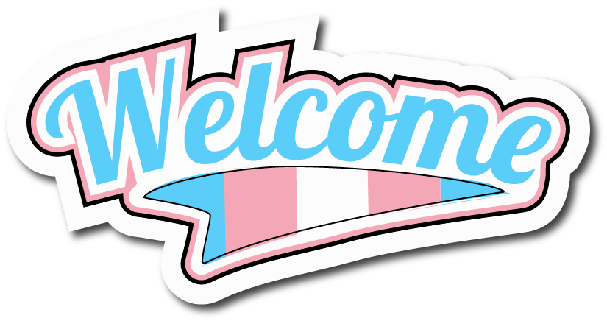

Developed by Gendered Intelligence:

Funded by Northern Ireland Human Rights Commission:

Including Transgender People
in Grassroots Sport

Contents

Introduction 2
Scope 4
What Does Transgender Mean? 5
Intersex People 7
Transition and Sport 8
Statistics on Transgender People in Sport and Physical Activity 11
Transgender Inclusion - What Might It Look Like? 12
Part 1: Participation-based Grassroots Policy 12
Part 2: Social Inclusion, Access and Support 18
Inclusive Sport Examples 22
Glossary 24
Further Resources 26
APPENDIX 1: Facilities – in more detail 28
APPENDIX 2: Language – in more detail 31
Descriptive terms 33
Managing mistakes 33
About Gendered Intelligence and The Northern Ireland Human Rights Commission 34

Introduction

Everyone involved in grassroots sport knows how amazing it can be, and how important and valuable it is in many people’s lives. It provides opportunities to be active and healthy; to find friends, build support networks and socialise; and to be part of something vibrant, challenging and fun.

Everyone should be able to play sport and enjoy all its many benefits.

“The practice of sport is a human right. Every individual must have the possibility of practising sport, without discrimination of any kind and in the Olympic spirit, which requires mutual understanding with a spirit of friendship, solidarity and fair play.”
International Olympic Committee

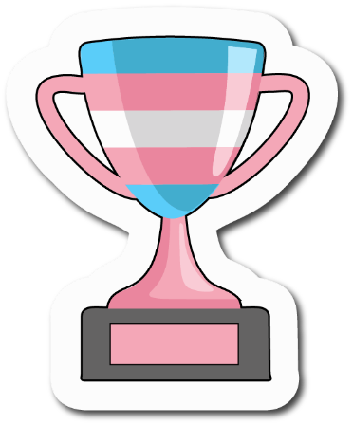

However, at this moment transgender people don’t always feel safe or welcome in sport. We know that it’s not unusual for transgender people to leave sports that they love because they can’t see a way to be themselves and still play. Others might like to try out a new sport, but find too many barriers, and too little information and visible support.

But it doesn’t have to be that way! Whilst including transgender people can sometimes feel challenging or daunting to start with, you don’t need to be an expert to make a real difference. There’s a lot that can be done inexpensively and straightforwardly to improve transgender people’s access to sport and welcome them into your setting.

Achieving inclusion does involve questioning some of our assumptions and stereotypes, taking the time to learn a little about the reality of transgender lives, and finding out what good transgender-inclusive practice could look like. It’s vital to support transgender participation, because sport is as important and valuable for transgender people as for anyone else.

“Sport has been a consistent and important part of my life since I was a young child. Since I was not academic, sport enabled me to build self esteem through my achievements on the sports field which compensated for the sense of failure I felt in other areas of school life. I suffer from mental health conditions such as anxiety and depression [and] sport has helped manage these conditions, relieve stress and channel my frustrations into healthy activities.
From puberty onwards I have suffered with gender dysphoria* relating to my body, and sport had enabled me to focus on what my body can do, rather than what it looks like, which has helped cope with dysphoria whilst waiting for hormones and surgery.
At both university, and afterwards when I moved to a new city, sports teams have been the easiest way for me to make friendship groups which I have otherwise struggled to do. This in turn has given me a support network and sense of community.”
Participant in a Gendered Intelligence survey, 2019
*‘Gender dysphoria’ is a medical term for the distress or unease sometimes associated with being transgender

Scope

This booklet is about transgender inclusion and experiences at grassroots level.
It sets out some of the key information it is useful for grassroots clubs, teams and other grassroots sporting organisations to know, along with some basic tips to help you make your sport, club or team more welcoming to transgender people.

It is illustrated throughout with quotes about real life experiences, most of which are taken from Gendered Intelligence’s own qualitative research about transgender people’s experiences in sport.

The considerations for elite sport, where very small differences in performance can have considerable impact, are not covered by this booklet. Governing Bodies looking to develop elite policy regarding transgender people are very welcome to get in touch with Gendered Intelligence.

This Guide is not intended to be relied upon as legal advice applicable to any individual case. The relevant legal and regulatory information is provided separately.

NOTE:

Owing to the nature of the funding for Gendered Intelligence’s sports research, the illustrative quotes are from people living in England and Wales. However, they are most likely closely reflective of Northern Irish experiences too.

Likewise, where statistics or other references have been used, whilst Northern Irish or Northern Ireland-inclusive figures have been referenced where possible, sometimes only global or English figures were available at time of writing.
Further research specific to Northern Ireland would be valuable.

What Does Transgender Mean?

Transgender is a term which can encompass a wide range of different experiences:

People who feel that the sex they were assigned at birth* does not match or sit easily with their sense of self (their gender identity) may use the term ‘transgender’ to describe themselves.

*in other words, what was put on their birth certificate when they were born

It can include:

- People assigned female at birth who recognise themselves to be men (who may describe themselves as transgender men, men of transgender history, men of transgender experience, or simply men)
- People assigned male at birth who recognise themselves to be women (who may describe themselves as transgender women, women of transgender history, women of transgender experience, or simply women)

But that’s not the whole picture. Not everyone’s sense of gender falls neatly into one of the two common options of man or woman.

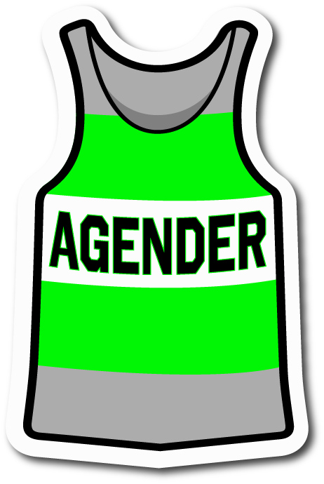
There is a wide range of different experiences of gender, such as:

- People who recognise their gender as beyond or between man or woman (who may describe themselves as non-binary)
- People who may experience different genders at different times (who may describe themselves as gender fluid).
- People who don’t experience a sense of gender at all, or only a slight sense of gender (who may describe themselves as agender)
- People who may be ‘gender questioning’ – exploring their gender with a view to understanding it more fully

Whilst not everyone who has one or more of these experiences uses the term ‘transgender’ to describe themselves, it is generally regarded as one of the broadest and most widely used single-word terms currently in use. As such, it is a good term to use in publicity for events, in guidance and policy, and other similar situations. It may be used on its own or in conjunction with other terms such as ‘non-binary’.

This publication uses the term ‘transgender’ in a broad way to refer to transgender men and transgender women, non-binary people, gender fluid people, agender people, those with dual-role and similar gender experiences, and anyone else with an experience of gender like or similar to the above.

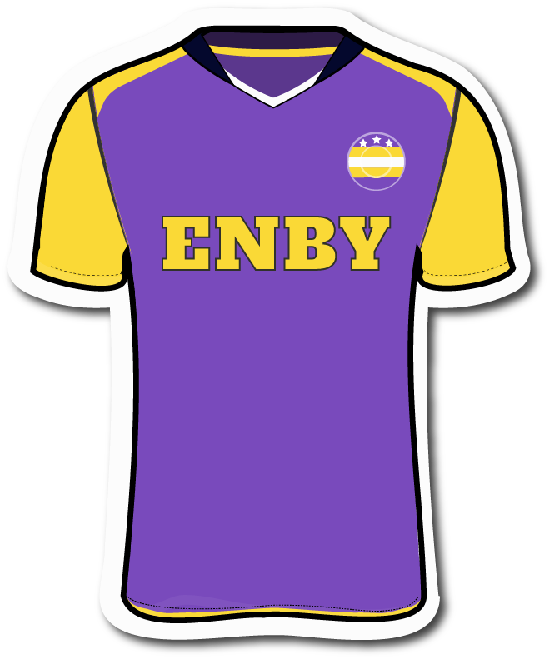
Statistics are not currently robust, however, it’s commonly estimated that around 1% of people fall within that broad description. However, there is growing evidence that transgender identities may be considerably more prevalent than that. A 2021 US study found over 9% of teens don't fully identify with the gender binary, and a 2022 US study found that 5% of young adults say their gender is different from their sex assigned at birth.

Combining with those experiences of gender are all the other aspects of people’s lives such as their age, faith, ethnicity, culture, economic circumstances, ability and class. None of us experiences our gender independently of these factors – they are inextricably interlinked. Any of them can act to alleviate or compound the issues someone faces in accessing sport.

All sports need to consider how they can be inclusive of all those different experiences of gender.

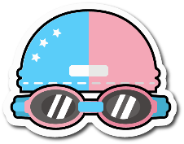
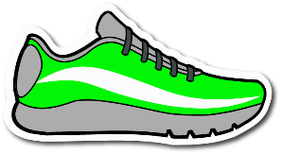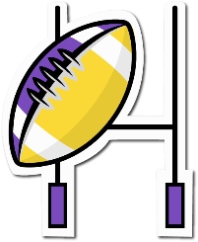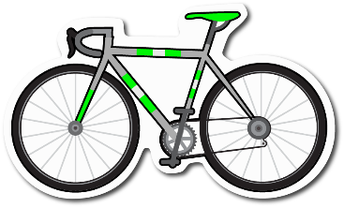

Intersex People

It’s important to note that being transgender and being intersex are different characteristics and relate to different experiences, although in sport people often think of the two together, and sometimes confuse or conflate them.

Intersex people are born with sex characteristics (including genitals, reproductive organs, hormone levels and/or chromosome patterns) that vary from typical binary notions of male or female bodies. Intersex is a term that encompasses a wide range of natural bodily variations.

Many intersex people grow up to have a distinct gender identity as a man or a woman, just as many other people do. Equally, some intersex people will grow up to have a non-binary or fluid gender identity. If an intersex person is assigned a sex that does not match their gender identity, they may view this as part of their intersex experience. Alternatively, they may view it as a transgender experience and may describe themselves as both intersex and transgender.

Some intersex sports people like Caster Semenya and Dutee Chand are well known because they have been the subject of considerable public speculation and invasive media attention about whether they ‘count’ as women for the purposes of sport. This attention, and the associated decisions of the relevant governing body, have been questioned by the UN as an infringement of their human rights.

Whilst transgender and intersex people are different, it is important to think about intersex inclusion when considering transgender inclusion, since policies and practices that affect one group often affect the other, especially in sport.

Transition and Sport

Some people transition. Transition means making changes to live your life in a way that’s better aligned with your gender identity.

These changes can be:

- Social (e.g. changing your name and/or pronoun; how you dress / present yourself; the gender on documents like your passport; which toilets you use)
- Medical (e.g. using hormones and/or surgery, or for young people, sometimes puberty-delaying treatment)
- Legal (e.g. changing your legal sex).

Some transgender people make a social transition and don’t seek medical support.

Of those who do use medical support, not everybody takes up every option, and people may use medical support in different ways. For example, some people may ‘micro-dose’ with hormones – this means taking smaller doses that create a hormone profile that falls outside typically male or female ranges. Some young transgender people may use puberty-delaying treatment to pause puberty and may experience only a partial puberty associated with their assigned sex.

However, sports quite often place their focus on medical transition, specifically testosterone levels, so it’s easy to see how eligibility criteria based on hormone levels can cause difficulties, or act as barriers to participation.

“Initial enquiries with [the governing body] were confusing and disappointing as it appeared as soon as I start hormones I couldn’t play for [the ladies’ team], but equally I had to apply to play [for the] men’s which may not be signed off for safety reasons. So I was left not being able to play at all.”
Participant in a Gendered Intelligence interview, 2019

Transition is therefore often a time when people are lost to sport.

Transgender women, who tend to be under most scrutiny in discussions around transgender inclusion in sport, can find themselves barred from women’s sport by blanket bans or by hormone-based eligibility criteria, or made so unwelcome that they can’t participate. In such circumstances they are faced with the choice of either giving up the sport, or playing on a men’s team which many find deeply inappropriate and too distressing to do.

“During transition I've received negative comments. I've also witnessed organised bullying of other trans women and exclusion from friendly competition. Rules on testosterone… could be used against me competing as female.”
Participant in a Gendered Intelligence interview, 2019

“I stopped engaging with sport after transition… The team were often homophobic and transphobic and I did not feel comfortable being with them or participating any longer.”
Participant in a Gendered Intelligence interview, 2019

Some transgender men don’t wish to move to the men’s team – they can find it too big a leap, at least to start with, and/or find the culture too ‘laddish’.

“I used to go boxing all the time, … and I used to be really good at it, and I think once I started taking testosterone, I sort of stopped because it was a weird in between where I couldn’t go to the women’s classes where I felt safe before to go to, but I also couldn’t go to the [men’s] classes because it was a bit intense.”
Participant in a Gendered Intelligence interview, 2019

Non-binary people may not find a workable place on gendered teams at all.

“I currently play hockey for a women's hockey team, despite the fact that I am non-binary. I have now started taking testosterone and I am painfully aware than my days on this team are numbered… The idea of leaving a team that has been my family for the last 5 years breaks my heart, but I feel I have no choice as sport is so heavily based on sex and gender. I am not willing to play for a men's team as I find it intimidating and don't identify as a man, so I feel my hockey playing days are over.”
Participant in a Gendered Intelligence survey, 2019

The benefits of sport include many social and support aspects, so requiring a transgender person to move teams as soon as they begin to transition medically is to cut them off from what is likely to be one of the key social networks they need at that time.

Policies and approaches that create a gap in practical access to gendered teams can push people towards delaying a transition that they want and need. A person may love their sport so much they can’t bear to give it up, and place their transition on hold to continue playing.

Paradoxically sport is the support network they need to move forward, but also the constraint that is holding them back.

People shouldn’t have to choose between playing sport and being themselves.

If a sport does decide it is necessary to put transition-related criteria in place, it is important to recognise the impact of that and to provide support and case by case flexibility to maximise retention at transition.

Statistics on Transgender People in Sport and Physical Activity

With such scenarios in mind, it’s not surprising that transgender people are particularly underrepresented in sport and physical activity.

Whilst figures show that on average 33% of men and 45% of women are not active enough for good health, this figure rises to 60% for transgender people, and 64% for those who don’t identify as either male or female.

When transgender people are present, they tend not to be open about being transgender. Where there is a fear that one might not be welcome, and/or intrusive evidence requirements, transgender people are likely to be taking part without disclosing their histories. The UK National LGBT Survey found that 62% of transgender people avoid being open about their gender identity at sports clubs or fitness / leisure facilities for fear of a negative reaction from others.

Transgender people’s fears are justified. Stonewall’s LGBT in Britain study found that 28% of transgender people have been discriminated against while exercising at a fitness club or taking part in group sport in the year prior to the study.

In turn, this is likely to bias participation towards transgender people who blend in with the cisgender majority both visually and in terms of performance. Not all transgender people look stereotypically transgender, and people are generally not questioned unless they stand out.
Transgender people are not only underrepresented at grassroots level, but throughout all sport including elite level. Over 54,000 Olympians took part in the Olympics between 2004 (when the IOC first set rules enabling transgender people to take part), and 2018. Based on the statistic of around 1% of the population being transgender, we should have seen several hundred transgender participants in that period. Instead, there were none as far as we know. There were just 4 transgender athletes in the 2020 Olympics out of 11,091 which is approximately a 27-fold under representation.

This shows very clearly there is an issue to be resolved. Far from being dominant as some people fear, transgender people are a group which is clearly finding it very difficult to access sport and should be supported, enabled and encouraged, just like every other under-represented group.

Transgender Inclusion - What Might It Look Like?

Having identified some of the issues and barriers transgender people may face in participating in grassroots sport, what can we do to improve the situation?

Here are some tips and ideas to help you. We begin with some thoughts about inclusion on a policy level and then cover the wider context such as facilities and use of language which are also necessary to enable that participation.

Part 1: Participation-based Grassroots Policy

- Good policy establishes practical ways for transgender people to participate and compete. Four factors are particularly important to keep in mind here:

  - The level of competition
We need to start where people enter the game – at grassroots. If the door isn’t open at grassroots level, we not only limit access to grassroots sport, but also close off the talent pipeline to elite level.

Historically, most sports have looked at transgender inclusion the other way round, beginning with elite sport, often driven by links to Olympic competition and the rules historically set there. That’s meant that what happens in elite sport – where tiny differences have a large impact - has usually cascaded down through all other levels without review or adaptation, or without questioning whether a different approach may be better suited at grassroots.

  - The variation of bodies and performance found at that level
At grassroots level, there are typically large and diverse differences between competitors, and a wide range of advantages and disadvantages unrelated to gender. Many grassroots sports, especially in youth, recreational and amateur settings, accommodate an enormous range of different capabilities and body types. Significant physical diversity is inherently part of grassroots sport and we can understand transgender people as forming part of that diversity.

  - Averages versus a spectrum - the assumptions we make
Despite the real-life diversity in grassroots sport, when discussing transgender inclusion there is often a focus on averages rather than the overall spectrum or range. Whilst, for example, we may find an average performance difference of 10% between cisgender men and cisgender women in a particular sport or discipline, this says nothing about the range of performances that makes up that average, nor about a particular individual and where they might fit into the overall picture.

Averages tend to lead to a blanket approach, whilst ranges enable us to take an individual approach. A focus on averages can lead to the blanket assumption that all transgender women will, for example, perform ‘10% better’ than their cis teammates or opponents, regardless of the actual performance of any given individual. This can lead to the further assumption

that an average difference between cis men and cis women implicitly makes it unfair or unsafe for an individual transgender woman to play on a women’s team or compete in a women’s league or division.

However, this does not take into account that some cis women could be performing at or above ‘10% better’ than that average too. The difference between two cisgender women on the same team can be considerably greater than the difference between the average cis man and the average cis woman. The cis male averages of, for example, height, weight or performance, may be found within the range of the women’s team or league or division.

It's important to remember that transgender women are not cis men and are all individuals.

So averages only have relevance at the macro or ‘population’ level, not at the individual level. We may therefore separate men’s and women’s competitions on the basis of average physical or performance differences, but having done that, no individual has to be average in order to take part. We don’t say, for example, that only women of average height or weight or skill can play women’s football.

  - The impact of social attitudes
Social attitudes have a part to play as well. Mostly the focus is on the inclusion of transgender women. The myth that all transgender women are disproportionately tall, heavy and strong, and dangerous to play with or against, is still a very current stereotype.

A small number of individual cases of transgender sports people, mostly at elite level, have also shaped perspectives. Their situations and lives have become the subject of media attention and debate in the public sphere, which has often been intrusive and harmful to the individuals concerned. Everyone is entitled to the right to a private life and no individual is representative of an entire community.

There are complex and nuanced discussions to be had about the best approaches towards transgender inclusion at elite level, and considerable research to do. Whilst some people may wish to raise questions around policies that enable transgender inclusion, this should be done on a general level with the policy makers and not enacted via direct challenge or attack on individuals.

- Think critically about safety and fairness
As described above, some of the biggest barriers transgender people face to inclusion are the assumptions people often make about whether it is safe and fair to include them in competition, as outlined above.

When playing sport, of course safety of participants and fair play are both important factors to consider generally, not just when thinking about transgender inclusion.
The question is: how do we assess those things? How do we assess the relative safety of different players, what do we actually mean by ‘fair’, and how do we apply those ideas fairly to transgender people?

Neither safety nor fairness are absolute, and both are contextual. We need to examine our understandings of what constitutes fairness and what creates safety and apply those understandings to everyone.

No sport is a level playing field – sporting success is inherently built on some people having advantages that others don’t have.

Risk is also an inherent part of many sports, however we act to limit it. At grassroots it is arguably much more associated with skill level – for example, being able to tackle safely – than with any physical variation of players.

In rugby, Craig Casey (height 1.65m, weight 76kg) and Will Carrick-Smith (height 2.11m, weight 129kg) would be allowed to play together. The average height of Dutch women is 72.4”, whilst the average height of Indonesian women is 62.2”, a difference of over 10”.

- Practical inclusion – start with an assumption of eligibility
Having thought critically about safety and fairness, can we start with an assumption of inclusion and non-discrimination at grassroots level, saying that people can play on the team that accords with / best matches their gender identity?

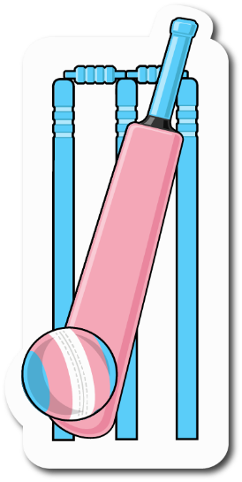
The English Cricket Board has set policy for recreational level cricket that includes transgender men and women in just that way. There are no medical requirements in place until someone reaches the pathway to international level where the ICC elite level medical criteria have to be met.

Roller Derby, a fast, contact/collision sport, says that anyone can take part in women’s flat track roller derby if that is the composition with which they most closely identify. Touch Rugby also supports people’s right to participate in Touch in a way that best reflects their gender identity, with non-binary people able to play in mixed, men’s or women’s according to their choice, again with no medical intervention needed. It’s clearly possible in a wide range of circumstances.

“Just see me as no different from any other woman.”
Participant in a Gendered Intelligence survey, 2019

“Accept me as a boy. Stand up for me against people who don't from other teams or parents etc. Not treat me any differently to the other boys on the team. Make sure I have the same uniform as the other boys.”
Participant in a Gendered Intelligence survey, 2019

- Make sensible assessments about ‘fit’ to enable good, meaningful competition.
What’s important is whether someone falls within the overall spectrum of possibilities for a particular (gendered) team, league, division or category. At grassroots, how often would a transgender woman fall outside the range of possibilities for other women, or a transgender man fall outside the range of other men?

It’s effectively about ‘fit’ to a team, league, division or category, just as it is for everyone – it’s about having a good, meaningful game or competition. This is essentially no different to the decisions about ‘fit’ made on a weekly basis for all kinds of reasons across playing fields and in competitions the length and breadth of Northern Ireland. Is someone too unfit, too big, too small, too lacking in skills, too injured to take part in a particular team or activity? Has someone outgrown a category and needs to move up a band?

- Consider non-binary inclusion.
All the above assumes binary options. Some non-binary people feel able to play on binary teams (for example Quinn, on the Canadian Olympic women’s football team). Others may not feel they fit within the traditional binary options at all.

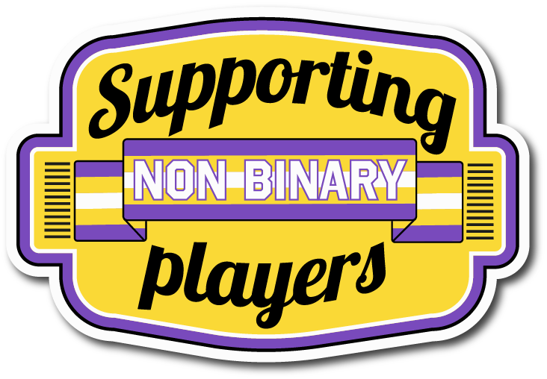
Softball has made strides towards non-binary inclusion by establishing rules which require no two players of the same gender to be next to each other when batting, and showing examples of batting orders which include non-binary players.

However, ‘mixed’ games are not inherently transgender inclusive, especially where rules set requirements for the number of players of each binary gender.
Developing non-gendered options provides full inclusivity for non-binary people. This may involve a considerable re-imagining of a sport, of what is valued, and of what creates success.

However, be careful not to make either mixed or non-gendered options the place where all transgender people are expected to participate.

- Consider young people’s participation.
It’s especially important that young transgender people should have access to sport and physical activity and feel included, welcome and safe when participating. Sport in general youth settings, including school, is at least as much about health, fitness, team work and social engagement as it is about competition.

PE staff are already used to differentiating their lessons to accommodate a very wide variety of abilities and ensuring everyone can take part:

- The single year age bracket of 14-15 year olds may include those who have barely started puberty and those who have almost finished
- Some young people may have physical health issues
- Some may have physical, sensory or learning disabilities

A few young transgender people may use puberty-delaying treatment (prescribed only after considerable medical assessment, and after puberty has begun) and so will experience only a partial puberty associated with their assigned sex.

It’s perfectly possible to include all those diverse experiences within youth sport.

However, we know many young transgender people avoid sport because of the difficulties they encounter. We know that engagement with sport begun at a young age often sets people up for a lifetime of positive physical and social activity. We also know that poor experiences when young can put people off for decades or for life.

“[I was] extremely uncomfortable in all sports lessons and activity in school- [I] avoided gendered changing rooms and the scrutiny of team sports – [I] would feign illness or genuinely make myself sick with panic attacks to get out of it. As an adult I’ve never shaken these associations. I cannot participate in competitive sports due to this anxiety…”
Participant in a Gendered Intelligence survey, 2019

Alongside this, general good practice when working with young transgender people is vital to enabling them to share their thoughts, feelings and needs, and to support them in the wider context of their lives. Some useful references are provided in the ‘Further Resources’ section.

- Recognise that transgender people are playing.
What is certain is that transgender people are playing, but we often don’t know they are there because they are not standing out, which implies they are falling ‘within range’.

- Take a lead as Governing Bodies.
Governing bodies should take a lead in working with grassroots sport, listening to their experiences and questions, and finding and learning from the case studies that demonstrate how transgender inclusion can work in practice. Give clear, inclusive, practical, sport-specific grassroots guidance (as distinct from elite competition regulations) so that grassroots people feel informed, supported and confident.

- Work with your Governing Bodies as grassroots clubs.
If you are in a grassroots club or team, you may be affiliated to a Governing Body that has (medical) eligibility criteria in place that currently apply at grassroots level, but that were set with elite or professional competition in mind.

You may consider that those criteria present unnecessary barriers and constraints in your setting and want to improve access and find ways to enable transgender people to play. The more clubs and teams bring those limitations to the attention of their governing body, and ask them to remove unnecessary restrictions for grassroots sport, the more inclusive sport will become. This is transgender allyship at a grassroots organisational level.

- If a sport does decide it is necessary to establish eligibility criteria at grassroots level, they should be carefully considered.
They should be legally compliant and grounded in human rights principles, based on relevant evidence, and allow for individual flexibility and a case by case approach. We are all different. Blanket or rigid approaches tend to rely on stereotypes, and/or on measurements such as current testosterone levels which, whilst easy to measure, are highly contested in terms of relevance. This inevitably doesn’t tend to achieve the best results.

Many sports already use weight categories, skill categories, handicaps and similar to ensure meaningful and safe competition. Approaching the subject creatively can open up opportunities to increase safety, fairness and equality for all.

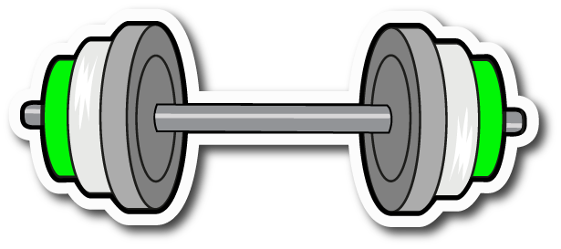

Part 2: Social Inclusion, Access and Support

Alongside basic access to play as described in Part 1, there are other things to consider to support transgender people to take part.

- Respect everyone’s gender identity, name and pronouns.
We can do this regardless of which team someone plays on. Quinn, a non-binary player on the Canadian women’s soccer team, is respected with their chosen name and with their chosen they/them pronouns.

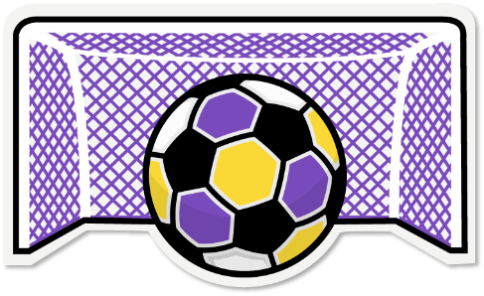

- Use language thoughtfully.
With individuals, take an ask, listen, respect approach - ask people’s name and pronoun (and their title if they use one), listen and remember, and then respect the person by using them. Sharing pronouns as part of the introductions when someone new joins the club or team is a great way to ensure everyone is clear what language everyone else wants used.

For general language or group language, it’s usually better to use gender neutral language. Saying ‘players’ instead of ‘ladies’ or ‘lads’ can help non-binary players feel more welcome on a gendered team.

More nuanced changes to language can have a big impact too. The difference between saying ‘the women’ and ‘the players on the women’s team’ may seem very small, but the second phrase acknowledges that not everyone on the women’s team is necessarily a woman.

- Make sure forms, databases and monitoring include options for everyone.
This includes providing options for non-binary people in both gender and title. Tick boxes for common options combined with a free text box is a good approach. This not only supports transgender people, but also anyone with less common titles such as ‘Lady’ or ‘Bishop’, or international titles, and those who may have official documentation of a gender other than M or F from other countries. A useful reference is provided in the ‘Further Resources’ section.

Some sports may be linked to national databases that have limited options. In these situations, think about what your local workaround might be. Can you keep a local spreadsheet? Can you act as an intermediary if for example, a non-binary person has to select ‘M’ or ‘F’ for a database which might be very difficult for them? Bringing these limitations to the attention of your governing body is a way to offer transgender allyship at an organisational level.

- Take confidentiality seriously. Everyone has a right to expect this, transgender or not.
The general rule is to only disclose someone’s transgender status / history with their consent. It’s not OK to question someone solely on the basis of their appearance, or question them about whether they are a person of transgender experience.

- Assume people choose the facilities that are the best fit for them out of the options available.
Think about the general privacy of the spaces you have - is there sufficient privacy for everyone? Privacy for all is good practice. Make sure there are gender neutral options for those who need them.

“I have stopped taking part in any activity where I suspect I could be outed. This particularly refers to any activity where I feel I might have to use communal changing or shower facilities. The level of anxiety I feel about this is too great to take the risk.”
Participant in a Gendered Intelligence survey, 2019

See Appendix 1 for more details and for ideas about facilities for clubs and teams.

- Consider sports kit.
Kit, strip and protective gear sizes and design can present barriers to people. Designs can assume the presence or absence of certain types of body parts such as breasts or genitals. Make sure there are options for everyone and enable everyone to choose freely from the list.

- Recognise situations where additional support may be needed.
Examples include:
- Overseas travel – is the country safe for transgender people? What are its laws and what is the general cultural approach to transgender people? It is important to consider what might happen if someone was taken ill and needed medical help, or if they were searched at an airport. Find out if someone can travel with their prescribed hormones - are they legal to bring into the country you’re visiting?
- Away matches – is the other team or setting transgender inclusive? What facilities do they have?
- Skills gaps – for example, some transgender women who join a netball team may not have had the opportunity to play before or may not know the rules. Likewise, a transgender man coming into the men’s athletics team may encounter different weights of implements. In addition, for some sports, activities can be radically different according to gender, for example gymnastics.

- Education and culture; addressing poor behaviour.
It’s important to become confident to stand up for transgender people’s inclusion and rights.

Educate people using information such as can be found in this booklet, so they know what’s appropriate behaviour and why it’s required. Ensure people have the opportunity to ask their genuine questions. We can’t hold people to inclusive standards of behaviour if we haven’t educated first.

Challenge poor behaviour if it arises, just as you would other behaviours such as racism, sexism, homophobia, Islamophobia etc.

- Publicise your inclusive practices and be visible in your allyship.
If people can’t see your inclusivity from the outside, they may still be anxious about approaching your club or team and may not even try to engage.
Visibility is key.
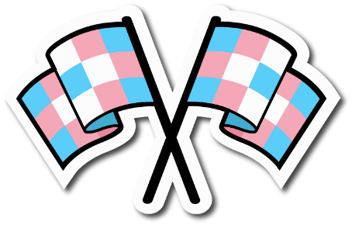
“I think the biggest thing is to be visibly supportive. I have no idea if anything happened, whether staff… have any awareness or would be understanding, stand up for me and support me. …
Recognise that this is something that can be a barrier to trans people accessing sports and the levels of stress, anxiety etc it can cause.”
Participant in a Gendered Intelligence survey, 2019

“I've been too scared to participate in sports with teams which were not explicitly trans inclusive.”
Participant in a Gendered Intelligence survey, 2019

Think about what is on your website:

- Is there an explicit statement welcoming transgender people, perhaps as part of a broader statement of welcome?
- Have you described your facilities and what’s on offer?
- Do you provide contact details of a named person to talk to?
- Have you got a visible code of conduct that sets out standards of behaviour that are transgender inclusive?
- Does the way you write about your teams / club use language thoughtfully?

Showcase what you can do, and if you have limitations, be honest about them.

Teams and individuals can also make their inclusion and allyship visible:

- When introducing new people to your club or team, use people’s pronouns e.g. "This is Jo, our club secretary, she uses she/her pronouns”
- Ask club / team members to share their pronouns along with their names e.g. “Let’s all introduce ourselves and share our pronouns”
- Add pronouns to email signatures / website profiles etc

- Celebrate and value transgender identities.
It’s important not to see transgender people as victims, but to celebrate and value them. When you’re ready, move beyond the basics of access and participation, and actively celebrate all the different forms of diversity in your club or teams, including transgender identities. Champion a culture of inclusivity for all.

Inclusive Sport Examples

Whilst sports with long-term embedded gender divides won’t change overnight, sports that have started in more recent times have been able to embed wider inclusion from the start.

Roller Derby, a fast, collision sport, is one such example. Regarding inclusion in the women’s team it simply says:

“An individual who identifies as a trans woman, intersex woman, and/or gender expansive may skate with a WFTDA (Women’s Flat Track Derby Association) charter team if women’s flat track roller derby is the version and composition of roller derby with which they most closely identify.”

As mentioned in an earlier section, Touch Rugby is inclusive on the basis of gender identity, and softball is a good example of mixed teams being thoughtful about non-binary inclusion.

Transgender people can have great experiences when peers, coaches and instructors are kind, thoughtful and inclusive and simply ask “What do you need? How can we make this work?”

“I was part of a wheelchair basketball team at University which was incredibly welcoming. The organisation running the league allowed for nonbinary genders when applying to play, and my whole team were really lovely, making sure people from other teams didn't misgender me and using inclusive language.”
Participant in a Gendered Intelligence survey, 2019

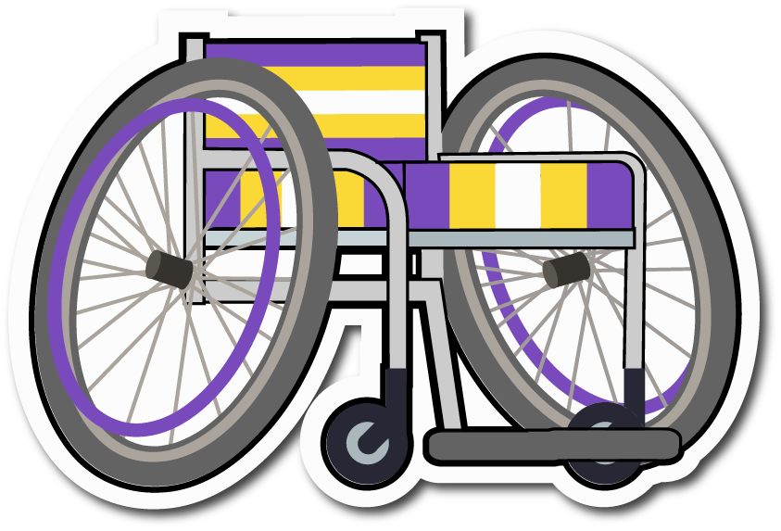
“I started doing taekwondo early in transition and the instructor was really supportive. He listened to concerns about binding when exercising and took that into account.
I was completely accepted as male in training and when being assessed.”
Participant in a Gendered Intelligence survey, 2019

Everyone in sport can do so much to enable participation and remove barriers.

“Trans people do face a huge number of issues in sport and in exercise and physical activity, especially in structured or group settings. … I think everyone can do more to try to be inclusive of trans people and not just to be accepting but specifically to reach out and create a space that is welcoming”
Participant in a Gendered Intelligence interview, 2019

“Inclusion is not bringing people into what already exists; it is making a new space, a better space for everyone.”
Dr. George Dei, Canadian Centre for Ethics in Sport,
“Creating Inclusive Environments for Trans Participants in Canadian Sport: Guidance for Sport Organizations”, 2016

Glossary

Transgender - People who feel that the sex they were assigned at birth does not match or sit easily with their sense of self (their gender identity) may use the term ‘transgender’ to describe themselves.

Non-binary - one of a number of terms people might use to describe the experience of having a gender that is neither male nor female, both male and female and/or between or beyond the binary categories of man and woman.

Gender fluid - one of a number of terms people might use to describe the experience of having a gender that varies. This may be variation over time, or in another way, for example according to different environments / settings.

Agender – one of a number of terms people might use to describe the experience of having no gender or very little gender.

Sex – the term usually used to refer to a person’s biological and physical characteristics, associated with the categories of male and female, based on, but not restricted to, reproductive function. It includes external genitalia, internal reproductive organs, chromosomes, hormones and secondary sex characteristics such as facial hair that typically develop around puberty.
In many circumstances, such as on registration forms and in relation to single sex spaces, it is often in practice used interchangeably with gender.

Gender – a wide-ranging term used to describe several different but intersecting aspects that are mainly social, cultural and behavioural:
Gender as a concept refers to the social and cultural ideas we hold about masculinity and femininity, and what it means to ‘be a man’ or ‘be a woman’. These ideas vary across time, across location and across cultures and are therefore often described as ‘culturally constructed’. Although it may be constructed, gender is both powerful and real. Gender affects almost every aspect of the world we live in, including goods, services, spaces, practices, laws and language.
When these ideas about gender become rigid and inflexible, they are often called gender stereotypes. These are the roles, interests, attributes and behaviours typically expected of a person based on other people’s perception of that person’s sex and/or gender. Stereotypes often limit or constrain a person’s life, closing down opportunities and self-expression and causing harm.

Gender as a sense of self (‘gender identity’) refers to a person’s inner and deeply held sense of themselves as, for example, a man or woman or non-binary person.

Gender as behaviours (‘gender expression’) refers to the cultural gender-related cues and behaviours a person uses, traditionally associated with masculinity and femininity, such as name, pronoun, title, clothing, hair, walk, speech, mannerisms and any other gendered aspects of presentation. It can also extend to which gendered spaces a person uses (such as toilets) and the gender they have on documentation (such as their passport and driving licence)
All these things intersect and are not experienced independently of each other.

Transition - Making changes to live your life in a way that better aligns with your gender identity. These changes can be:

- Social (e.g. changing your name and/or pronoun; how you dress / present yourself; the gender on documents like your passport; which toilets you use)
- Medical (e.g. using hormones and/or surgery)
- Legal (e.g. changing your legal sex)

Cisgender / Cis - one of a number of terms people might use to describe the experience of having a gender that matches their sex assigned at birth in the typically expected way. In other words, a man assigned male at birth, or a woman assigned female at birth.

NOTE: It is important to have a term to describe this life experience, because otherwise the norms associated with it can be invisible, and the privileges attached to it can be taken for granted.

Intersex – one of a number of terms people might use to describe the experience of being born with sex characteristics (including genitals, reproductive organs and/or chromosome patterns) that vary from typical binary notions of male or female bodies. It is a term that encompasses a wide range of natural bodily variations. Other terms include VSD (Variations of Sex Development) or DSD (Differences of Sex Development). Note that DSD meaning ‘Disorders’ of Sex Development is generally to be avoided.

More extensive glossaries including descriptive terms:

Gender: A Few Definitions – Brook

Brook is a charity that works with and for young people and has produced a very useable glossary
https://www.brook.org.uk/your-life/gender-a-few-definitions/

Transgender Language Primer

The Transgender Language Primer is a very extensive glossary, designed to “document the movement to express and identify the complexity of gender while acknowledging its history and intersections”
https://translanguageprimer.com

Further Resources

Rainbow Project –works to improve the health and well-being of LGBTQIA+ people and their families in Northern Ireland; excellent listing of transgender groups here:
https://www.rainbow-project.org/trans-and-non-binary-support-organisations/

TransUnite – UK wide, searchable listing of transgender support groups – a good gateway to find a range of local help including youth support
https://www.transunite.co.uk/

Transgender NI - Support and information for transgender people; runs the Belfast Trans Resource Centre
https://transgenderni.org.uk/

Focus The Identity Trust – Support for transgender and intersex people
https://www.thefocustrust.com/

Sporting Pride - LGBTQ+ Sport for the whole Irish community
https://www.sportingpride.ie/
See especially “Transgender Participation in Sport” video panel discussion, 26/05/21

Transgender Network Ireland (TENI) – transgender organisation
https://www.teni.ie/
See especially “The Post-primary School Experiences of Transgender and Gender Diverse Youth in Ireland Report” 2020 including ‘PE and Sports Participation’ section p33; and “Transgender athletes - Sara Phillips of TENI joins OTB Sports' Nollaig na mBan” video discussion 10/01/21

Non-Binary People, Sport & Physical Activity - Pride Sports, 2021
Fuller detail on non-binary inclusion, with more examples
https://pridesports.org.uk/wp-content/uploads/2019/05/Non-binary.pdf

Pronoun App - Minus 18 (Australia)
A tool to introduce and practice using pronouns
www.minus18.org.au/resources/online-activity:-a-guide-to-pronouns

Gender Construction Kit (England and Wales)
For those wishing to understand more about the practical aspects of transition, including medical options, this site is excellent. It’s also a good place to signpost transgender people to for initial information. However, please remember that not all transitions involve medical intervention.
https://genderkit.org.uk/

Equality Commission for Northern Ireland – general equalities body with a statutory remit to promote equality and address complaints
https://www.equalityni.org/Home

Irish Human Rights and Equality Commission - Ireland’s national human rights and equality institution
https://www.ihrec.ie/
Gendered Intelligence Links

Transgender Inclusive Images – free-to-download sporting images
https://genderedintelligence.co.uk/sport/images.html

A suite of 36 transgender inclusive sports images, each available in transgender, non-binary and agender flag colours (108 images in total).

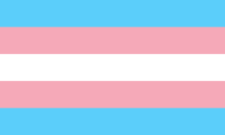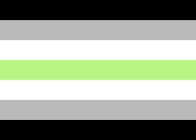
Transgender flag Non-binary flag Agender flag

Any organisation or club wishing, for example, to run a transgender inclusive event, publish transgender inclusive guidance, or have a page welcoming transgender participants on its website, is welcome to download these for free. There's something for every club, sport, event and activity.

(The images in this publication are taken from this resource)

Resource List for Professionals
and
Good Practice when Working with Young Trans and Non-binary People

These and other downloads are available from:
https://genderedintelligence.co.uk/professionals/resources.html

Gendered Intelligence’s Approach to Working with Young People in Schools and Colleges

This page sets out how Gendered Intelligence approaches transgender and wider LGBTQI+ inclusion when working with young people. The points are of relevance to any professional working with young people.

You can either access the information via a series of mini videos, or download a full set of transcripts, references and a glossary as a single pdf via a link on the page.
https://genderedintelligence.co.uk/education/approach.html

APPENDIX 1: Facilities – in more detail

Both transgender people and the clubs/teams they might be playing for, often have questions about inclusivity of facilities – changing spaces, showers and toilets.

This appendix sets out some basic principles to follow, alongside some practical suggestions that will help you to work with your current facilities to be as inclusive as possible, recognising that funds to upgrade them may be very limited.

Everyone should be able to change, shower and use the toilet in an environment that is safe and welcoming for them. This typically means reasonable privacy and an environment where there is a code of conduct about agreed behaviours.

If there's not enough privacy for a transgender person, there's not enough privacy for anyone so it's something that needs addressing generally.

“I currently swim and … I am often nervous in the changing rooms, as there are no cubicles available and the showers are open plan. … This is always a point where I feel exposed and vulnerable and I just have no idea how people might react”
Participant in a Gendered Intelligence survey, 2019

There are plenty of people who dislike open changing or showering facilities for all kinds of reasons, so good privacy supports everyone’s access to those spaces. Many people who aren’t transgender found it distressing to have to change or shower in front of others at school, and as adults still dislike those open settings. For example, lots of people come to gyms ready-changed and then go home to shower and change afterwards.

It's also important to ensure that behaviours in such settings are appropriate. This can mean setting codes of conduct around nudity and ‘banter’ for example. This also helps address ‘laddish’ behaviours that can be very off-putting for some men, but which are often dismissed as ‘just part of sport’. If we focus on behaviours not bodies, we typically create much more welcoming, safer spaces.

Regardless of what changing options you can offer, develop a culture where you accept people choose the right facilities for them out of the options available. It’s not good practice to call people out on the basis of their appearance.

“I was supported fully by the leisure centre I used throughout my transition. Occasionally people would complain about me being present in ‘wrong sex’ areas such as changing rooms. They were given short shrift by the centre staff.”
Participant in a Gendered Intelligence survey, 2019
Transgender people will have different views on what would make them feel safe and comfortable. We need to open up options so that everyone has something that works for them.

If you have gender segregated facilities, transgender women should have access to women’s facilities; transgender men should have access to men’s facilities.

Non-binary people typically need gender neutral facilities. If you have a non-binary identity, then walking through a men’s or women’s toilet or changing room door can feel like declaring a gender that you don’t have, and may feel (and be) unsafe. Gender neutral facilities can also support access for other transgender people.

“There are no gender neutral changing facilities at my gym so I have to get changed at home. At work I have to do an annual fitness test which forces me to pick a binary gender, this … makes me feel uncomfortable and extremely anxious.… I feel uncomfortable using gendered changing facilities.”
Participant in a Gendered Intelligence survey, 2019

“[There are no] gender neutral changing areas at the pool. I pass when dressed but I’m pre op so when I go swimming I prefer to just wear a swim suit. If there is no gender neutral changing rooms I can’t use the pool because as a man I cannot go into the women’s changing room, but a person in the men’s cannot walk out in a swimsuit.”
Participant in a Gendered Intelligence survey, 2019

In general, binary gendered, communal / open facilities are the least accommodating for transgender people and hardest to work with. Binary gendered spaces are, by nature, not accommodating of non-binary people, and any space with limited privacy tends to be challenging for transgender people.

The ideal is to upgrade to a universal, all-gender changing village configuration with individual cubicles. Fully enclosed, fully private changing spaces of variable sizes can meet all needs. For example, it supports parents bringing older children who are of a different gender but who are still young enough to want to be with their parent; disabled people who may have a Personal Assistant or carer of a different gender; and people of faith who may have a requirement for a single-sex space – the ultimate single-sex space is a space with no-one else in it.

This configuration also tends to be space efficient – if you have one changing village, you don’t need two lobbies etc.

Whilst most venues don’t have the money to do this immediately, it’s important to make sure that if the opportunity for a rebuild or refurbishment arises, that discussions about all-inclusive design are brought up early on. Such conversations should be considered at the planning stage and reflected in any tender for work.

Newer buildings may be gender segregated, but are typically designed with enclosed cubicles that provide good privacy for all. This means you may be able to designate (some) facilities as gender neutral just by changing some signage.

If there’s no immediate prospect of an update, and facilities are gender segregated with shower arrangements or changing facilities that are fully open, consider changing them to cubicles. If that's outside current budgets, consider adding some inexpensive curtaining to make some 'soft' cubicles which provide increased privacy.

However, gender segregated facilities don’t address the needs of non-binary people or anyone else who wants or needs non-gendered options. It can be useful to think of as many options and strategies as you can come up with and make sure you have some suggestions to offer if, for example, someone asks for gender neutral changing, or separate changing space, to ensure you are as accommodating of those needs as possible.

In older buildings, you may need to be a little more creative – if you have non-gendered accessible facilities, you could redesignate them as ‘accessible and gender neutral’. However, this isn’t ideal as it can impact on those who need those particular facilities for other access reasons.

If it’s really hard to redesignate facilities, for example because the accessible facilities are embedded in gendered spaces, think about other spaces you could convert or use – for example officials’ changing areas, staff changing areas, other appropriate rooms etc. Take a walk around the facility - what spaces have you got that could help meet the need?

If a venue is open for particular events, like a yoga session, or a cricket match, you can offer a time period either before or after others get changed when transgender people can get changed if they prefer. But this is much less than ideal.

Bear in mind that it's not acceptable to ask people to change in a toilet.

If a transgender person approaches you to find out what options are available, ask what would make them most comfortable, and accommodate that where possible. Be prepared to be flexible.

Whatever space you have, educating other users can be part of the picture. If transgender people are stared at, or complained about, or told they are in ‘the wrong space’, then they are unlikely to feel welcome. However, when educating make sure you discuss principles not individual situations. Care must be taken not to compromise the confidentiality of any individual transgender people.

Publicise your practices and what you can offer.
APPENDIX 2: Language – in more detail

Language related to transgender people and transgender experiences is often a concern for people. Language is in rapid evolution – new words are appearing, existing ones are changing meanings, and there is inconsistent use of terms. It can seem like there are hundreds of words. People don’t want to get it wrong, but what does ‘right’ look like? How do we manage language in such a state of flux?

Here are some top tips aimed at giving you confidence and a workable approach.

We can think of language around transgender people as falling into three main types:

- Everyday language – the key language that you need on an everyday basis to interact with people. This is typically their name, pronoun (e.g. he, she, they), and sometimes their title (e.g. Mr, Mrs, Doctor).
- Descriptive language – language which people use to describe themselves to others and to themselves, sometimes linked to a sense of identity. This is the area where there are dozens if not hundreds of terms. It’s the language that is evolving fastest.
- “Ideas” language – language which is important because it enables us to think or talk about key ideas relevant to transgender people’s experiences and lives. This includes terms like sex, gender identity, gender expression, transgender, transition, non-binary and cisgender. These are all set out in the Glossary. There is only a handful of terms in this category, so they are manageable to get to grips with.

It's useful to expand on the other two areas of ‘Everyday’ and ‘Descriptive’ language:

Everyday Language

Individuals

The most important language to get right is someone’s name and pronoun.
It’s also important to get other gendered terms right such as the title someone uses.

Whilst everyone should have their name, title and pronoun respected, when a transgender person transitions, using their new name, pronoun and title are among the most supportive things you can do - it shows that you are seeing the person as they see themselves. It makes them feel welcome and safe. To a transgender person, it can feel like becoming visible for the first time when someone uses the name and pronoun they’ve chosen.

Equally, it’s really important not to use someone’s old name and/or pronoun, even when talking about the past. This can not only be very hurtful to the person, but can ‘out’ them (disclose that they are transgender without their consent) and in some circumstances make their life unsafe. When done negligently or deliberately to cause offence or harm this is called ‘deadnaming’.

People who have a non-binary identity may ask for people to use a gender neutral pronoun and / or a gender neutral title. ‘They’ is now a common gender neutral pronoun. It was recently word of the year in the US Meriam Webster dictionary. There are others, such as xie, ind or per, but they are less common – if someone uses one of those terms, and you’re not sure how to use it, just ask politely, or look them up on Google. You’ll find examples of how to use and pronounce them. There’s also a helpful link in the Resources section.

There are also gender neutral titles – some gender neutral titles already exist (e.g. Professor, Reverend, Doctor) but aren’t open to many people. Mx, often pronounced ‘Mix’ or ‘Mux’, was first introduced in the 1980s and is increasingly common.

However, not all non-binary people use gender neutral pronouns or titles. Likewise, not everyone who uses gender neutral pronouns or titles is non-binary. Pronouns and titles don’t tell you someone’s gender identity.

Ask, listen, respect

Getting gendered terms right implies you need to find out which terms someone uses, so don’t be afraid to ask: “Do you use a title?” “Can I check which pronouns you use?” “How do you like to be addressed?” You can also offer your own pronouns as an indication people are welcome to share theirs.

There are several ways such practices can be embedded as an ordinary part of your everyday culture. For example, when introducing new people to your club or team: "This is Jo, our club secretary, she uses she/her pronouns”; adding pronouns to email signatures / website profiles etc; and making it common practice to share pronouns along with names at the start of a season “We have several new members, so let’s all introduce ourselves and share our pronouns”.

Start with gender neutral language

Until you know someone’s choices, it’s best to avoid assumptions of gender and use gender-neutral language.

Not everyone who sounds masculine is male; not everyone who sounds feminine is female; avoid terms such as ‘Sir’ / ‘Madam’ or ‘this gentleman’ / ‘this lady’, at least until someone makes it clear what their chosen terms are.

It takes a little practice to use gender neutral terms such as ‘I have a young player here for you’ instead of ‘I have a young man here to see you’, but it is simple to achieve and can make a lot of difference.

“Feel very uncomfortable and anxious about joining new teams or clubs because they often misgender me in front of everyone and assume my gender before I can correct them.”
Participant in a Gendered Intelligence survey, 2019
Groups

Assumptions of gender can also appear in collective terms. Single sex or binary phrases like ‘Welcome, ladies and gentlemen’ aren’t inclusive of non-binary people. “Good morning, everyone” is a simple, polite alternative.

On the sports pitch, think about using terms such as ‘folks’, ‘people’, ‘players’ and/or ‘everyone’ instead of terms like ‘lads’, ‘ladies’, ‘guys’ or ‘girls’. Some teams use their team names, e.g. “C’mon Tigers!”

Descriptive terms

People are often worried about how to manage the many descriptive terms that exist.

Our advice here is not to try and learn all the terms – it’s unnecessary. Most of the time you have no need to know whether someone describes themselves as demi-boy, genderqueer, neutrois, enby, or any one of dozens of descriptions that exist across the UK and across the world. You’re interacting with them as an individual via a name and pronouns.

Instead, develop a strategy for finding out what terms to use and what they mean in those few situations where you’ll need them. The golden rule is listen, don’t label.

If particular terms come up in interactions, listen to how someone describes themselves. If you’ve never heard those terms or aren’t sure what they mean – it’s OK to ask! Even if you do know the term, asking is a good way to check that your understanding and theirs are the same.

There are fuller glossaries online too –skimming a couple can be a good way to get a flavour of the diversity of experiences people may have, and to see the different way terms are understood. There are some example links in the resource list.

The right term to use is the one the person chooses or asks you to use. Remember that every person is a person – not just a label.

Managing mistakes

We all make mistakes; we all can inadvertently use a term, or phrase, or question someone reacts to – that’s not specific to transgender people.

It takes a little practice if you’re used to using a previous name and pronouns for someone, so you might accidentally slip up a few times to start with.

It’s perfectly acceptable to apologise and move on. Don’t over-apologise or try to rationalise any mistake; equally don’t over-worry or expect to get it right first time the whole time. Do make every effort to get it right as soon as you can.
About Gendered Intelligence and
The Northern Ireland Human Rights Commission

Gendered Intelligence is a registered charity that works to increase understandings of gender diversity and improve the lives of transgender people.
We are based in England, working throughout the UK, and occasionally more widely.
We are transgender led, with a diverse range of professional and academic qualifications alongside in-depth and in-breadth lived experience and community connections.

We offer a broad spectrum of non-judgmental, practical services to the public, private and not-for-profit sectors, designed to increase understandings of gender diversity, and to develop, improve and enhance transgender inclusion. We do this through providing consultancy, information, guidance and training. We also work directly with hundreds of transgender people every year, especially young transgender people, which informs our service provision.

In the sport sector, we have worked with national governing bodies, leisure centres, university sports facilities, swimming facilities, school / college PE staff, architects specialising in sport facilities, and local grassroots clubs; and have direct experience of providing sporting and residential opportunities for young transgender people.

GI welcome constructive feedback, and contributions which will help everyone build good trans-inclusive practice in this evolving area of inclusion.
Users of this guide are welcome to contact GI with such comments. This input will help develop a second edition in due course.

Contact Us
https://genderedintelligence.co.uk/contact/contact.html

The Northern Ireland Human Rights Commission (NIHRC) promotes and protects the rights of everyone in Northern Ireland.

NIHRC is an independent public body and a national human rights institution with A status accreditation from the United Nations (UN).

The NI Sports and Human Rights Forum is a multi-stakeholder membership, which is supported by the Human Rights Commission. It enables sporting bodies, grassroot sporting groups, public authorities, government representatives and civil society to engage with each other on sport and human rights issues. It focuses on sharing information and examples of best practice.
https://nihrc.org/

Including Transgender People
in Grassroots Sport

This document has been developed by Gendered Intelligence (GI) and funded by the Northern Ireland Human Rights Commission (NIHRC).

The NI Sports and Human Rights Forum is a multi-stakeholder membership, which is supported by NIHRC. It enables sporting bodies, grassroots sporting groups, public authorities, government representatives and civil society to engage with each other on sport and human rights issues. It focuses on sharing information and examples of best practice.

In February 2022, the Forum discussed gender identity and sport. Following the meeting, several Forum members asked for more guidance on transgender inclusion in grassroots sport. Consequently, the Commission contracted and funded England-based charity Gendered Intelligence (GI) to develop this resource. The Human Rights Commission thanks GI for its work and hopes the resource is a practical tool for sports governing bodies as they develop their own agreed policies on gender identity in sport.

The guide is intended to offer some of the key information it is useful for grassroots clubs, teams and other grassroots sporting organisations to know, along with some basic tips to help you make your sport, club or team more welcoming to transgender people.

© Gendered Intelligence 2023
Gendered Intelligence is a Registered Charity in England and Wales No. 1182558.
Registered as a Company Limited by Guarantee in England and Wales No. 06617608.
Registered office at VAI, 200 Pentonville Road, London N1 9JP.

Gendered Intelligence ‘Resource List for Professionals’, p37 – Prevalence Statistics references: https://genderedintelligence.co.uk/professionals/resources.html
Prevalence of Gender-Diverse Youth in an Urban School District, 2021, American Academy of Paediatrics: https://www.them.us/story/high-schooler-gender-diversity-study US Pew Research Center survey, 2022: www.pewresearch.org/fact-tank/2022/06/07/about-5-of-young-adults-in-the-u-s-say-their-gender-is-different-from-their-sex-assigned-at-birth/
“Enby” (on the T-shirt image) is a word some non-binary people use to describe themselves – a phonetic spelling of “nb”
UN Office of the High Commissioner for Human Rights https://www.unfe.org/wp-content/uploads/2017/05/UNFE-Intersex.pdf
United Nations open letter to the IAAF regarding Caster Semenya, 2018 https://www.ohchr.org/sites/default/files/Documents/Issues/Health/Letter_IAAF_Sept2018.pdf
United Nations Background Note on Human Rights Violations against Intersex People, 2019, p31-32 https://www.ohchr.org/sites/default/files/Documents/Issues/Discrimination/LGBT/BackgroundNoteHumanRightsViolationsagainstIntersexPeople.pdf
In the UK, the Gender Recognition Act 2004 enables people to change their legal sex. However, very few transgender people do so. Legal sex affects very little in practical terms, the process is currently intrusive and bureaucratic, and there is as yet no option for non-binary people.
English figures, likely to be broadly indicative of NI experiences: ‘Lesbian, Gay, Bisexual and Trans People and Physical Activity: What You Need to Know’, National LGB&T Partnership, 2016, referencing Health Survey for England, 2012, and the Partnership’s own survey of LGBT people, 2015 https://nationallgbtpartnershipdotorg.files.wordpress.com/2016/02/lgbt-people-and-physical-activity-what-you-need-to-know.pdf
National LGBT Survey, Government Equalities Office, 2018, Table 5.1, inclusive of Northern Ireland: https://www.gov.uk/government/publications/national-lgbt-survey-summary-report
LGBT in Britain: Hate Crime and Discrimination, 2018, Stonewall https://www.stonewall.org.uk/lgbt-britain-hate-crime-and-discrimination
https://en.wikipedia.org/wiki/Craig_Casey
https://en.wikipedia.org/wiki/Will_Carrick-Smith
World Population Review: https://worldpopulationreview.com/country-rankings/average-height-by-country (note average difference between men and women globally is only 5”)
https://resources.ecb.co.uk/ecb/document/2020/03/16/dbf9fbc2-d56d-429a-b48d-562064b1ecc8/2020-ECB-Policy-on-Trans-People-Playing-Cricket.pdf
https://resources.wftda.org/womens-flat-track-derby-association-statement-about-gender/
https://www.englandtouch.org.uk/media/1953/eta-transgender-non-binary-gender-diverse-policy_212605.pdf
https://www.npr.org/2021/08/06/1025442511/canadian-soccer-player-quinn-becomes-first-trans-and-nonbinary-olympic-gold-meda
https://www.baseballsoftballuk.com/document/inclusive-softball-rules-lgbtq-committee
https://wftda.com/wftda-gender-statement/
https://cces.ca/sites/default/files/content/docs/pdf/cces-transinclusionpolicyguidance-e.pdf

