

Dear Stakeholder,
Thank you for taking part in our Strategic Planning Process 2025 – 2028.

The aim of this process is to shape our focus and direction for the next three years and to ensure the overall mission and values of the Human Rights Commission remain the right ones, which are then achieved in practice.

The Commission has a broad mandate with many statutory duties to fulfil. Not least the Commission has a duty to advise government on the legislation and actions needed to respect, protect and fulfil the human rights of everyone in Northern Ireland.

We want to hear what you think about our priorities and help us decide how we fulfil our obligations. In doing so, please bear in mind that our overall purpose is to promote and protect the human rights of everyone in Northern Ireland.

Tell us what is concerning you in your community, or what issues are most affecting you or your organisation. Even if you are unsure whether it is a human rights issue, you should still let us know. Human rights run through every part of society and are at the heart of every part of our daily lives.

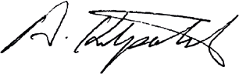
Yours Sincerely,


Alyson Kilpatrick
Chief Commissioner
Northern Ireland Human Rights Commission

