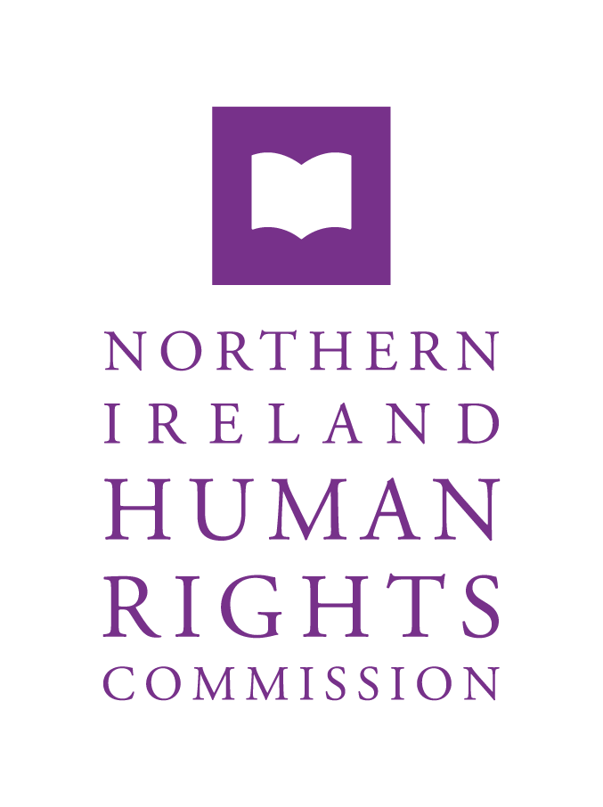

**Call for Expression of Interest on a Cost/Benefit Analysis for Women’s Health Interventions in NI**

**October 2024**

**The Northern Ireland Human Rights Commission is seeking to contract research relating to women’s health in NI.**

**The deadline for submitting a quotation is 12:00 noon on 11 November 2024. This should be submitted via email to** [**accounts@nihrc.org**](mailto:accounts@nihrc.org)**.**

# Background

* 1. The Northern Ireland Human Rights Commission (the Commission) is a national human rights institution (NHRI) accredited with A status by the Global Alliance of National Human Rights Institutions. In common with all national human rights institutions the Commission has a range of statutory functions aimed at promoting and protecting human rights. For example, the Commission, pursuant to section 69(1) of the Northern Ireland Act 1998, reviews the adequacy and effectiveness of law and practice relating to the protection of human rights in Northern Ireland (NI). In accordance with section 78A(1) of the Northern Ireland Act the Commission monitors the implementation of Article 2(1) of the Protocol on Ireland/NI of the UK-EU Withdrawal Agreement (Protocol Article 2) to ensure there is no diminution of rights protected in the ‘Rights, Safeguards and Equality of Opportunity’ chapter of the Belfast (Good Friday) Agreement 1998 as a result of the United Kingdom (UK)’s withdrawal from the EU. The Commission exercises this mandate alongside the Equality Commission of Northern Ireland (ECNI), as part of the ‘dedicated mechanism’ framework.
  2. Pursuant to Section 69(6)(a) of the NI Act 1998, the Commission is seeking to conduct research to explore the issue of human rights and women’s health in NI. This is also in line with the Commission’s strategic objective to keep under review law and practice and advise government for the benefit of everyone in NI.
  3. Northern Ireland is currently the only region of the UK and Ireland without a specific women’s health strategy, despite calls for a strategy on women’s health to be introduced.[1] In February 2024, the then Minister for Health, Robin Swann MLA, announced that the Department of Health NI was developing a Women’s Health Action Plan, specifying that the Department was doing so within a difficult budgetary period.[2] The then Minister noted that the development of the Action Plan would sit alongside a listening exercise in relation to women’s health, conducted across NI by Queens University Belfast and Derry Well Women.[3] The Commission notes this development and is focused on ensuring that this research project does not duplicate work ongoing elsewhere.

# Research Aims

* 1. The aim of the research is to explore the barriers to accessing healthcare for women and girls in NI to inform the development of a specific strategy to tackle health-based inequalities faced by women and girls in NI. The research should add to the existing body of research exploring the gender health gap in the UK. Noting current budgetary pressures, the research should consider the principle of progressive realisation of the right to health to the maximum available resources of the State.[4] The project should present findings on current health outcomes for women and identify gaps. The project should identify how health inequalities impact on women’s enjoyment of rights. Furthermore, the research should explore potential policy solutions to address inequalities.
  2. The project will provide a cost/benefit analysis, or similar model, of women’s health interventions to identify whether a comprehensive and fully funded women’s health strategy could be a more effective use of government resource. This should:
* Provide a baseline assessment of gaps in access to healthcare for women and girls in NI and their consequences. This should include where there is a lack of data or costings available, or an absence of an appropriate justification as to why such gaps exist;
* Establish what benefits, if any, could be gained from implementing specific and tailored women’s health intervention models in NI. These could be benefits at an individual, societal or governmental level and do not have to be limited to economic benefits;
* Establish whether an adequately funded women’s health strategy in NI is an effective use of government resources, while considering carefully the limitations of economic arguments when deciding on the allocation of public funding;
* Consider what constitutes gender budgeting and its relevance to public policy making in relation to healthcare in NI;
* Consider models of best practice across the UK and Ireland and internationally where relevant, including an assessment of their transferability to the NI health system;
* Consider costs incurred by the healthcare system in NI where women and girls have experienced barriers to accessing specialised healthcare; and
* Consider obstacles to healthcare in NI for marginalised groups including minority ethnic communities, LGBTQIA+ women, women and girls living in poverty, rural women and girls and d/Deaf or disabled women and girls.

# Focus of the Research

* 1. This research should focus on findings and proposed recommendations that are relevant in the context of Northern Ireland.
  2. Examples from other jurisdictions are useful where they can offer examples of best practice or provide useful insights. It may be useful to include examples of how other strategies on women’s health from other jurisdictions of the UK have been costed and funded and whether conclusions can be drawn on their effectiveness.
  3. It is not expected that the researcher will provide detailed financial appraisals. Estimates of existing costs and potential savings utilising a robust and credible methodology are anticipated.
  4. The Commission anticipates that the research will undertake broad analysis of the provision of healthcare, which should include preventative and curative care. The research should explore the physiological differences between women and men which impact on access to healthcare, namely reproductive health, menstruation, menopause, cancers which are specific to women etc, and also socio-economic factors, including for example, the experience of poverty, the effect of different cultural traditions and the effect of violence against women and girls.
  5. The Commission is aware that a woman or girl’s health can have a knock-on effect in other aspects of their life, particularly if they are experiencing temporary or persistent poor health. By extension, this can require additional steps by or support from the State outside of healthcare, which carry costs. It would be useful where this applies for it to be highlighted, including relevant examples. However, this should be by way of illustration, to highlight linked research or to flag other areas that require research, with the focus of this research primarily on women’s health in NI.
  6. The Commission seeks to ensure that this research adds to existing levels of knowledge and understanding and does not seek to duplicate existing research set out in paragraph 1.3.
  7. The Commission does not anticipate that the research will include a human rights-based analysis of the right to health. The focus of this research tender is to conduct a cost/benefit analysis of women’s health to inform a strategy on women’s health for NI.

# Specification

* 1. The successful contractor will be required to:
* Engage with the NIHRC to clarify the parameters of the project;
* To undertake both desktop research and any potential interviews with key stakeholders, which may include civil society organisations, practitioners, service providers, academic or policy makers in this field; and
* Submit a robust draft report by 31 March 2025 at the latest and, having taken account of the Commission’s comments and subject to discussion between the Commission and the contractor, a final report by 31 May 2025, which includes findings on costs and benefits associated with an effective women’s health strategy for NI and, if relevant, proposed recommendations on how to effectively resource a women’s health strategy.
  1. The Commission retains all rights to the intellectual property and will be responsible for future decisions regarding the publication of the report, this includes whether the findings of the research are published, the content and format of any publication and how publications or other outputs are disseminated. In all publications or other outputs, the role of the contractor will be duly acknowledged.
  2. Further dissemination opportunities may follow from this research in the form of a seminar and/or round table event, which will be hosted and funded by the Commission.
  3. The Director of Research, Policy and Investigations will be available to liaise with the successful contractor for the duration of the project, to resolve any queries concerning the research or the Commission’s requirements in respect of the final draft.

# Application

* 1. Interested parties are invited to:

1. Write a brief letter of motivation, alongside an annex of relevant experience and publications (no more than four pages in total). It is expected that interested contractors will provide an outline of the proposed approach to the project, including the methods they will employ for ascertaining and ensuring that the Commission’s requirements are met. At minimum, the letter should demonstrate:

* experience of each member of the research team in undertaking research in one or more of the following fields (to ensure coverage across of the range of relevant experience):
  + the NI legislative and policy framework, including knowledge of how this operates as a devolved region of the UK;
  + experience using economic models in relation to public policy;
  + gender sensitive policy making, including gender budgeting.
* Knowledge and understanding across the research team of key issues relating to women’s health, including its impact on specific groups;
* Ability to develop feasible proposals for action on women’s health in NI;
* An understanding of the Northern Ireland Human Rights Commission’s statutory functions and mandate;
* Detail on how they will conduct the research within the time available, including a proposed outline methodology and how the research team will ensure the research adds value to pre-existing research;
* how value for money will be ensured; and
* how quality assurance will be guaranteed.

1. Quote a fixed price of no more than **£30,000** (inclusive of VAT) for researching, writing and presenting a final report in line with the terms of reference. The proposed cost should provide a breakdown of how many days will be allocated to specific tasks undertaken by research team members, alongside a daily financial rate for each researcher. The proposals will be assessed for value for money.
2. Provide an example detailed workable timeframe, in line with the deadlines set out above for the interim and full report.
3. Provide details of two referees who can comment on the interested contractors’ ability to deliver the research and output described in the above specification.
   1. The award of the contract will be based on:

* the applicants’ competence to undertake the work, judged from the content of the letter of motivation and previous experience;
* how effectively the proposal will be delivered in practice; and
* value for money.
  1. The Commission reserves the right not to accept the lowest quotation.

# Policies

**Human Rights Policy**

* 1. Tenderers must confirm that their organisation has a human rights policy. Tenderers who have been selected will be asked to provide a copy of their organisational human rights policy prior to award of contract.

**GDPR Policy**

* 1. Tenderers must confirm that their organisation has a GDPR policy. Tenderers who have been selected will be asked to provide a copy of their organisational GDPR policy prior to award of contract.

**Any questions about the project should be emailed to** [**Emma.Osborne@NIHRC.org**](mailto:Emma.Osborne@NIHRC.org) **and** [**Hannah.Russell@NIHRC.org**](mailto:Hannah.Russell@NIHRC.org) **who will arrange a prompt response.**

1. Katie Andrews, ‘Calls for NI to have a ‘women’s health strategy’, *UTV News*, 17 October 2023.
2. Department of Health ‘Press Release: Minister Swann outlines Women’s Health Action Plan’, 13 February 2024.
3. Department of Health Press Release: Minister announces public listening exercise of women’s health’, 5 March 2024.
4. See Article 2 of the International Covenant on Economic, Social and Political Rights.