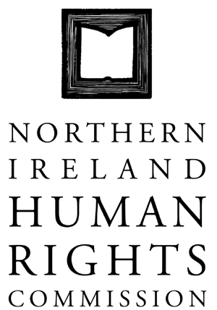

144th COMMISSION MEETING

HELD ON MONDAY 17 DECEMBER 2012 AT 10.00AM AT THE OFFICES OF THE NORTHERN IRELAND HUMAN RIGHTS COMMISSION, TEMPLE COURT, 39 NORTH STREET, BELFAST, BT1 1NA

Present: Professor Michael O’Flaherty, Chief Commissioner
John Corey
Alan McBride
Milton Kerr
Marion Reynolds
Paul Yam
Grainia Long

In Attendance: Virginia McVea, Director
David Russell, Deputy Director
Rebecca Magee, Executive Assistant
Claire Martin, Communications Worker
Angela Stevens, Caseworker (Agenda item 6)

Apologies: Christine Collins

1. Minutes of the 143rd Meeting

1.1 The minutes of the 143rd Meeting were adopted following minor amendments.

2. Matter arising

2.1 Further to the discussion at the 143rd meeting (HRC144.1 point 6.2) Commissioners noted the position of the EHRC at this time and agreed not to intervene in the legal case.

3. Chief Commissioner Report

3.1 Commissioners noted the Chief Commissioner’s report on his meetings since the last Commission meeting. These included:

- Transitional Justice Roundtable event with Priscilla Hayner
- Fundamental Rights Agency Conference in Brussels on “Justice in austerity - challenges and opportunities for access to justice”
- Meeting with Junior Ministers of OFMDFM
- Representatives from the Ex Prisoner Working Group of OFMDFM
- Ad Hoc Committee on Welfare Reform
- Keynote speaker at a conference on the Human Rights of Freedom of Religion or Belief, Geneva

4. Commissioner Report

4.1 Commissioner Alan McBride reported on the Transitional Justice Roundtables that he chaired with Priscilla Hayner.

4.2 Commissioner Milton Kerr attended the Stephen Livingstone Lecture at Queens University and a lecture on Women’s Rights at University of Ulster.

4.3 Commissioner Kerr and Commissioner Paul Yam attended the British-Irish Intergovernmental Christmas reception.

4.4 Commissioner Marion Reynolds attended the Ministerial Forum on Safer Custody. She outlined issues relating to the health needs of prisoners and recommended that early in the New Year the Commission responds to an open invitation from NIPS to visit the Donard Centre.

5. Quarterly Report against the Business Plan

5.1 Commissioners noted the Quarterly Report against the Business Plan.

5.2 Commissioners discussed with the Director the early indication of success in the bid to the NIO for Web design.

Action: Further discussion needed at the January Commission meeting on the Web design bid.

6. Implementing the Detention Strategy

6.1 Commissioners discussed requests for training and possible extension of training.

6.2 Commissioners agreed that a review of the Detention Strategy should happen in the New Year.

7. Irish Language consultation response

7.1 Commissioners accepted the consultation response following an amendment to add an agreed additional paragraph.

8. Ulster Scots consultation response

8.1 Commissioners accepted the consultation response following an amendment to add an agreed additional paragraph.

9. Devolved Jurisdictions

9.1 Nothing to report.

10. Any other business

10.1 Commissioners discussed further community engagement events.

Action: Dates for further engagement to be arranged.

10.2 Commissioner Paul Yam raised concerns about the Access to Health Care for Minority groups.

Action: Commissioner Yam and the Director are to meet to discuss.

11. Strategic Planning with Staff

11.1 The afternoon was committed to a human rights based approach to strategic planning.

11.2 Commissioners and Staff met to discuss Strategic Planning.

Approved: _____________

Date: _____________

