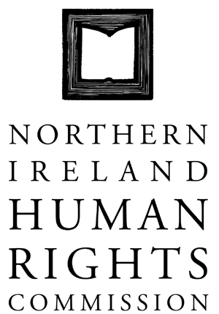

145th COMMISSION MEETING

HELD ON MONDAY 14 JANUARY 2013 AT 10.00AM AT THE OFFICES OF THE NORTHERN IRELAND HUMAN RIGHTS COMMISSION, TEMPLE COURT, 39 NORTH STREET, BELFAST, BT1 1NA

Present: Professor Michael O’Flaherty, Chief Commissioner,
John Corey
Alan McBride
Milton Kerr
Christine Collins
Paul Yam
Grainia Long

In Attendance: Virginia McVea, Director
David Russell, Deputy Director
Rebecca Magee, Executive Assistant
Claire Martin, Communications Worker
Angela Stevens, Caseworker (Agenda items 6+8)
Rhyannon Blythe, Assistant Caseworker (Agenda items 6+8)
Nazia Latif, Investigations Worker (Agenda item 12)

Apologies: Marion Reynolds

1. Minutes of the 144th Commission meeting

1.1 The minutes of the 143rd Commission meeting were adopted following minor amendments.

2. Matters arising

2.1 Transitional Justice Report – The first draft of the report should be with Commissioners at the end of February.

3. Chief Commissioner report

3.1 Commissioners noted the Chief Commissioner’s report on his meetings since the last Commission meeting. These included:
- Attendance at the Commission for Victims and Survivors roundtable discussion on Sectarianism, Hate Crime and Social Networking.
- Meetings at the Foreign and Commonwealth Office, London.

4. Commissioner update

4.1 Nothing to report.

5. Directors Report

5.1 Commissioners noted the Directors report.

5.2 Commissioners congratulated the Director on the success of Website and Social Media bid and City of Culture bid.

6. Functions Report

6.1 Commissioners noted the Functions report.

6.2 Commissioners discussed the progress of the Investigation into Hate Crime.

6.3 Commissioners discussed ongoing legal cases.

6.4 Commissioners discussed consultation responses.

7. Strategic Planning update

7.1 Commissioners discussed the Draft Strategic Plan document in detail.

7.2 Commissioners approved the Draft Strategic Planning document following amendment for the next round of public consultation.

8. Legal Strategy

8.1 Commissioners noted the Legal Strategy document.

Action: Legal Strategy to be put on the agenda for the March Commission Meeting.

9. Web Design and Social Media tender update.

9.1 Commissioners noted the update in relation to the Web Design and Social Media tender.

10. Annual Statement update

10.1 Commissioners noted the Annual Statement update.

10.2 Commissioners noted that a second distribution would happen by the end of January.

11. Parliamentary report

11.1 Commissioners noted the Parliamentary report.

12. Service Level Agreement (SLA) with Northern Ireland Ombudsman update

12.1 Commissioners noted the update on the operation of the SLA.

12.2 Commissioners discussed with the Director the strategic context of the SLA.

Action: Updates are to be provided to the Commission on a bi-monthly basis.

13. Any other Business

13.1 Commissioners discussed the upcoming visit of the UN Special Rapporteur on the rights to freedom of peaceful assembly and of association.

13.2 Commissioners discussed the upcoming visit of Rosslyn Noonan and the objectives of the visit.

13.3 Commissioners noted the UK Bill of Rights Commission report had been launched.

Action: Hard copies of the report to be requested for Commissioners.

13.4 Commissioners discussed the recent decision to separate the Housing Executive.

Action: Meetings to be requested with DSD and the Housing Executive.

13.5 Commissioners discussed the recent Flag Dispute. Commissioners endorsed all the statements issued by the Chief Commissioner on the issue.

Action: Chief Commissioner and Director to meet with the Equality Commission and CRC.

