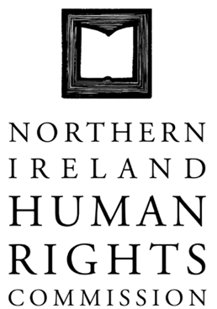

SPECIAL COMMISSION MEETING HELD ON 30 AUGUST 2013 AT 1:00PM IN THE OFFICES OF THE NORTHERN IRELAND HUMAN RIGHTS COMMISSION, TEMPLE COURT, 39 NORTH STREET, BELFAST, BT11NA

In attendance: Professor Michael O’Flaherty
Grainia Long
John Corey
Marion Reynolds
Milton Kerr
Christine Collins
Alan McBride
Paul Yam

Present: Virginia McVea
Kellie Turtle (Agenda item 4)

Apologies: David Russell

1. Discussion on Interim Planning

1.1 The Commissioners agreed that managing the interim period pending the appointment of a new Chief Commissioner is of critical importance.

1.2 Pending the taking up of post by the next Chief Commissioner the Commissioners decided to appoint from within its own membership an Acting Chairperson.

1.3 Under direction of the Commissioners the Acting Chairperson will work in close cooperation with the Director to lead the Commission.

1.4 Commissioner John Corey was proposed as acting chair person. This proposal was endorsed by acclamation.

1.5 The Chief Commissioner and the Director assured Commissioners that they would take every step possible to ensure the smooth and effective transition.

1.6 Commissioners assured Mr Corey of their ongoing support.

1.7 Mr Corey will take up this role from 1 November 2013.

1.8 Commissions in September will consider an appropriate remuneration package.

2. Recruitment

2.1 Commissioners agreed to refer to the previous process and seek assurance that same will be expedited by the Secretary of State.

2.2 Commissioners agreed to ensure clarification on the website in late October that Mr John Corey will be in the position of Acting Chairperson.

The Chief Commissioner left the meeting at 2:30.

3. Annual Statement

3.1 Commissioners discussed the Annual Statement launch event and agreed that Mr Corey will speak with Professor O’Flaherty about the arrangements.

Commissioner Paul Yam left the meeting and the Chief Commissioner re-joined the meeting at 3:00.
Kellie Turtle, Education Worker joined the meeting at 3:00.

4. Right to Culture Paper

4.1 Commissioners opened the Right to Culture paper for general comments.

4.2 Ms Turtle introduced the paper.

4.3 The paper is in 5 sections:
- Frameworks
- Consideration of how frameworks have been applied internationally.
- Focus on past conflict context
- Case Study
- Conclusions and Recommendations

4.4 The paper is proposed to be tabled at the UN Human Rights Council in March 2014.

4.5 Commissioners agreed the paper will be adopted no later than mid-October.

4.6 Commissioners agreed that we would host a panel event in Geneva to have an event with the Special Rapporteur, Ms. Farida Shaheed.

4.7 Commissioners discussed drafting comments that were noted by Ms Turtle.

4.8 The Chief Commissioner undertook to write the shorter version of the report required for UN purposes before the end of October.

Meeting closed at 3:50.

