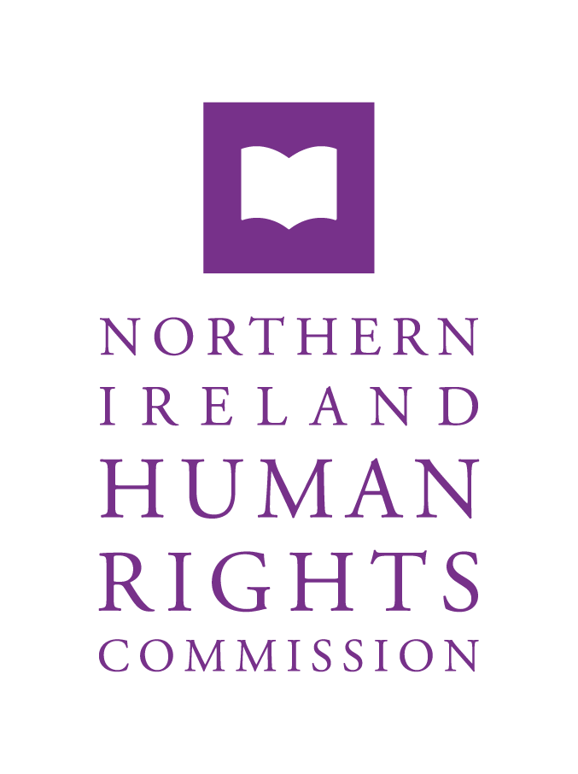

**Response to the UK Government’s Follow-up Report to the UN CEDAW Committee’s 2019 Concluding Observations on the United Kingdom of Great Britain and Northern Ireland**

**September 2021**

**Table of Contents**

1.0 Introduction 2

2.0 Recommendation 1: Incorporation of the provisions of the Convention into national legislation 3

3.0 Recommendation 2: Impact assessment of EU Exit on rights of women 3

Article 2 of the Ireland/Northern Ireland Protocol 3

Equality Impact Assessment 4

Impact of the UK’s withdrawal from the EU on women in NI 5

4.0 Recommendation 3: Inclusion of the provisions of the Convention, ECHR and the *acquis communautaire* in domestic legislation 6

European Convention on Human Rights and the Human Rights Act 1998 7

Retained EU Law 8

# Introduction

* 1. The Northern Ireland Human Rights Commission (the NIHRC) is one of three A-status National Human Rights Institutions in the United Kingdom (UK). Established in 1999, the NIHRC, pursuant to Section 69(1) the Northern Ireland Act 1998, reviews the adequacy and effectiveness of law and practice relating to the protection of human rights. The NIHRC’s mandate extends to all matters relating to the protection and promotion of human rights in Northern Ireland (NI), within the competence of the NI Assembly and the Westminster Parliament. The NIHRC, pursuant to section 78A(1) of the Northern Ireland Act 1998, must monitor the implementation of Article 2(1) of the Protocol on Ireland/Northern Ireland in the EU Withdrawal Agreement (rights of individuals).
  2. This submission provides a response to the UK Government's follow-up report on the implementation of four recommendations from the UN Committee on the Elimination of Discrimination against Women (UN CEDAW Committee) in its Concluding Observations on the UK in March 2019.

# Recommendation 1: Incorporation of the provisions of the Convention into national legislation

* 1. The NIHRC remains concerned that the UN human rights treaties, including CEDAW have not been incorporated into UK domestic law. The NIHRC recognises the devolved governments of Scotland and Wales are taking steps towards incorporation of the CEDAW into domestic legislation.[1]
  2. The NIHRC continues to call upon the NI Assembly to take steps to embed CEDAW obligations into domestic law and policy, particularly following the UK withdrawal from the European Union (EU).

# Recommendation 2: Impact assessment of EU Exit on rights of women

## Article 2 of the Ireland/Northern Ireland Protocol

* 1. Article 2 of the Protocol requires the UK government to ensure no diminution of rights, safeguards and equality of opportunity, as set out in the Rights, Safeguards and Equality of Opportunity chapter in the Belfast (Good Friday) Agreement 1998, results from the UK’s withdrawal from the EU.
  2. Article 2 commits the UK government to keep pace with six non-discrimination EU Directives listed in Annex 1 of the Protocol (Annex 1 Directives).[2] Therefore, should the EU decide to amend or replace the substantive rights in the Annex 1 Directives to improve the minimum level of protections, legal protections in NI will also be enhanced to reflect these improvements.[3]
  3. There are additional EU obligations that are relevant to the Rights, Safeguards and Equality of Opportunity chapter of the Belfast (Good Friday) Agreement, which is given effect in NI through retained EU law or domestic provisions. While the UK Government has said that it does not envisage any rollback of these provisions post-Brexit, it acknowledges that these fall within scope of the Government’s no-diminution commitment under Article 2.[4] There is not the same obligation to keep pace with these provisions of EU law as there is with the Annex 1 Directives, meaning mechanisms to ensure women’s rights in the EU may move beyond these provisions and there will be no obligation to mirror this improvement in NI.[5]
  4. The NIHRC, along with the Equality Commission for Northern Ireland (ECNI), has been given a new mandate under the EU (Withdrawal Agreement) Act 2020. The NIHRC welcomes this new mandate, which grants both Commissions new powers to monitor, advise, report on, promote and enforce the implementation of Article 2 of the protocol as part of its ‘dedicated mechanism’ framework.

## Equality Impact Assessment

* 1. The NIHRC notes that the equalities assessment referenced in the UK Government’s follow up report provides impact analysis on legislation from 2017. The impact analysis refers to the European Union (Withdrawal) Act introduced under the former government, while the more recent EU (Withdrawal Agreement) Bill, introduced to Parliament in 2019, was not accompanied by an equality impact assessment.[6]
  2. The equalities assessment does not consider the specific impact of the UK’s exit from the EU on women in devolved nations, including NI per the UN CEDAW Committee’s recommendation. The devolved administration in Scotland carried out its own social and equality impact assessment of the UK’s withdrawal from the EU, identifying that the State’s equalities assessment did not differentiate impacts on a group-by-group basis.[7]
  3. The follow-up report by the UK Government references the equality protections under the Equality Act 2010. The NIHRC notes that the Equality Act 2010 does not have jurisdiction in NI. Unlike the rest of the UK, there is no single legislative instrument to consolidate, clarify and enhance existing equality protections in NI. In NI, discrimination is prohibited by a complex framework of laws and regulations.[8]

## Impact of the UK’s withdrawal from the EU on women in NI

* 1. Civil society organisations in NI have identified a number of key concerns regarding the impact of leaving the EU on women. One issue they have raised is the loss of funding from the European Social Fund. The Fund would have provided resources for a number “wrap-around services” which benefit women, including childcare provision.[9] Post-Brexit, the UK has sought to replace the European Social Fund with the UK Shared Prosperity Fund (UKSPF). While money from the European Social Fund was sent to devolved administrations who then determined how it was allocated, the UKSPF will operate through a single UK-wide framework, with little input from devolved administrations.[10]
  2. Civil society organisations have expressed concern for gender equality now that the UK has withdrawn from the EU Charter of Fundamental Rights and the European Union Court of Justice.[11] They note that both have been instrumental in “driving forward domestic legislation in the UK to a more substantive application of equality and human rights for women”.[12] Additionally, the sector has noted that, while the gender equality framework under Article 2 of the Protocol provides a floor of protection, there are additional EU protections that have not been guaranteed under Article 2 that would have benefited women in NI such as the Work-Life Balance Directive.[13] The NIHRC notes that the UK Government has accepted that EU obligations in effect on 31 December 2020, which underpin the rights, safeguards and equality of opportunity section of the Belfast (Good Friday) Agreement, fall under the no-diminution commitment in Article 2 of the Protocol.[14]
  3. Civil society organisations in England have identified specific concerns around the impact of the EU Settlement Scheme on migrant women experiencing domestic abuse, which has exacerbated existing barriers to accessing support services and rendered some women unable to access the necessary documentation to apply.[15] The NIHRC is concerned that given the difficulties faced by migrant woman experiencing domestic abuse that similar unrecorded issues may be faced by migrant women in NI.
  4. **The Committee may wish to recommend that the UK Government provide additional information on the impact of the withdrawal of the UK from the EU on women, including women in NI.**

# Recommendation 3: Inclusion of the provisions of the Convention, ECHR and the *acquis communautaire* in domestic legislation

* 1. While the UK ratified the CEDAW in 1986, it is not incorporated into domestic law, and has not indicated that it intends to do so.
  2. In a response to a recent consultation on a Bill of Rights for NI[16] conducted by a committee of the NI Assembly, the NIHRC recommended that a Bill of Rights should further entrench protections that largely exist in domestic law to reflect the UK’s international human rights obligations.[17]

## European Convention on Human Rights and the Human Rights Act 1998

* 1. In its follow-up report, the UK Government references its Independent Human Rights Act Review (IHRAR). The Terms of Reference for the IHRAR identified that the Review would not look at the content of the rights, but would consider the operational mechanisms of the Human Rights Act 1998 (HRA).[18]
  2. The NIHRC responded to the IHRAR Call for Evidence[19] identifying the incorporation of the ECHR as a key commitment in the Belfast (Good Friday) Agreement which recognised the centrality of rights, which was incorporated through the HRA and NI Act 1998.[20] The continuing centrality of human rights protections through the Belfast (Good Friday) Agreement is evidenced through the UK Government’s commitment to no-diminution of rights in Article 2 of the Ireland/Northern Ireland Protocol in the EU-UK Withdrawal Agreement 2020. The NIHRC cautioned against any changes to the operation of the HRA which could diminish human rights protections in NI, including inhibiting access to remedies for ECHR violations.[21]
  3. **The Committee may wish to request additional information from the UK government regarding the impact any potential changes to the operational mechanisms of the HRA will have on women, including women in NI.**

## Retained EU Law

* 1. The UK has not retained the entirety of the acquis communautaire in its domestic legislation after its exit from the EU.[22] However, as the UK Government’s follow-up report identifies, some EU law in place on exit day has been retained in UK law.[23] This EU law provides a baseline of rights, however, it will not develop beyond this baseline, as it will in the EU. This is evident with the new EU Directive on Work-Life Balance, which repeals the Parental Leave Directive.[24]
  2. The EU Charter of Fundamental Rights was not carried over into domestic law as part of EU retained law as the UK left the EU, with references to the Charter in case law now being read as general principles.[25] However, the Charter still has relevance to the UK-EU Withdrawal Agreement, including the Protocol and to any EU measure made applicable by it.[26]
  3. The UK Government introduced regulations to extend the power to depart from retained EU case law to additional courts, including the Court of Appeal NI.[27] Following the UK withdrawal from the EU there is a risk that as the UK amends and updates retained EU law over time that it could repeal or amend a provision that leads to a diminution of rights, safeguards and equality of opportunity and therefore engage Article 2, without adequate parliamentary scrutiny.[28]
  4. **The Committee may wish to recommend that the UK Government provide additional scrutiny on any change to retained EU law that engages Article 2 of the Ireland/Northern Ireland Protocol of the EU-UK Withdrawal Agreement 2020, particularly on secondary legislation, in respect of its impact on women.**

**Contact us**

[www.nihrc.org](http://www.nihrc.org) | [info@nihrc.org](mailto:info@nihrc.org) | +44 (0)28 9024 3987

4th Floor, Alfred House, 19-21 Alfred Street, Belfast, BT2 8ED



1. In Scotland, through the National Taskforce for Human Rights Leadership in March 2021, incorporation will be taken forward by a new Human Rights Bill, as part of a broader incorporation of rights. In Wales, research has been commissioned on options to advance equality and human rights, including the possible incorporation of UN conventions into Welsh law.
2. Four of these Directives provide a framework of gender equality standards, including; Directive 2004/113/EC on Gender Goods and Services; Directive 2006/54/EC on Equal Employment between men and women; Directive 2010/41/EU on Equal Treatment between men and women in self-employment; and Directive 79/7/EEC on equal treatment between men and women in matters of social security’
3. The UK government has agreed to dynamically align with the Annex 1 Directives to ensure that at least the minimum standard of rights protections will be relevant in NI, ensuring “NI will not fall behind minimum European Standards in anti-discrimination law”. Northern Ireland Office, “Explainer: UK Government commitment to no diminution of rights, safeguards and equality of opportunity in Northern Ireland” (NIO, 2020), at para 12; Article 13(3) of the Protocol clarifies that where there are references to EU measures in the Protocol, “that reference shall be read as referring to that Union act as amended or replaced”.
4. Northern Ireland Office, “Explainer: UK Government commitment to no diminution of rights, safeguards and equality of opportunity in Northern Ireland” (NIO, 2020), at para 13.
5. Directive (EU) 2019/1158 of the European Parliament and of the Council of 20 June 2019 on work-life balance for parents and carers and repealing Council Directive 2010/18/EU; The Parental Leave Directive falls within the scope of Article 2. The Work-Life Balance Directive will repeal the Parental Leave Directive, yet there is no obligation on the UK Government to keep pace with these new provisions.
6. UK Government, ‘Equality Analysis: European Union (Withdrawal) Bill,’ (UKG, 2017).
7. E Hepburn, ‘Social and Equality Impacts of Brexit’, (Scottish Government, 2020), at 5.
8. See Employment Equality (Age) Regulations (NI) 2006; Disability Discrimination Act 1995; Special Educational Needs and Disability (NI) Order 2005; Equal Pay Act (NI) 1970; Sex Discrimination (NI) Order 1976; Race Relations (NI) Order 1997; Fair Employment and Treatment (NI) Order 1998; Employment Equality (Sexual Orientation) Regulations (NI) 2003; Equality Act (Sexual Orientation) Regulations (NI) 2006; NI Act 1998.
9. Women’s Policy Group NI, ‘NI Covid-19 Feminist Recovery Plan: Relaunch – One Year On’, (WRDA, 2021), at 296.
10. House of Commons Library, ‘the UK Shared Prosperity Fund: Briefing Paper’, (HoL, 2021), at 15. The focus of the UK wide framework for the UK Shared Prosperity Fund has only been set out in broad terms with little detail available. It will focus on investment in people, such as work-based training and will include some support for early years; investment in communities and infrastructure and investment for local business. A second strand of funding will be targeted to people most in need through bespoke employment and skills programmes.
11. The Commission would note that, under article 4 of the UK-EU Withdrawal Agreement 2020, both the European Charter of Fundamental Rights and CJEU jurisprudence still have relevance to the Withdrawal Agreement, including the Ireland/Northern Ireland Protocol and any EU obligation made applicable by that Agreement.
12. Women’s Policy Group NI, ‘NI Covid-19 Feminist Recovery Plan: Relaunch – One Year On’, (WRDA, 2021), at 296.
13. Women’s Policy Group NI, ‘NI Covid-19 Feminist Recovery Plan: Relaunch – One Year On’, (WRDA, 2021), Plan at 299.
14. Northern Ireland Office, “Explainer: UK Government commitment to no diminution of rights, safeguards and equality of opportunity in Northern Ireland” (NIO, 2020), at para 13. The NIHRC is currently undertaking further work to examine the scope of Article 2 and relevant underpinning EU obligations.
15. [Refuge,](https://www.refuge.org.uk/eu-settled-status-domestic-abuse-risk/) ‘Refuge reports that many survivors of domestic abuse are yet to apply for Settled Status and fear this will put vulnerable families at further risk’, (Refuge, 2021); There are reports that some women have been coerced by abusers into believing that they are no longer able to contact the police or access healthcare services due to the UK’s withdrawal from the EU.
16. Consideration of a Bill of Rights for Northern Ireland was a commitment under the Belfast (Good Friday) Agreement 1998. An Ad-Hoc Assembly Committee was created to consider the creation of a Bill of Rights under the New Decade, New Approach Agreement 2020.
17. Belfast (Good Friday) Agreement, 10 April 1998, Part 6 on Rights, Safeguards and Equality of Opportunity – Human Rights, para 4. NI Human Rights Commission, ‘Response to the Ad Hoc Committee’s consultation on a Bill of Rights for Northern Ireland’, (NIHRC, 2021).
18. Independent Human Rights Act Review Team, ‘Terms of Reference’, (MoJ, 2021).
19. NI Human Rights Commission, ‘Submission to the Independent Human Rights Act Review Team’s Call for Evidence (NIHRC, 2021).
20. The Belfast (Good Friday) Agreement 1998 section on Rights, Safeguards and Equality of Opportunity created a duty on the UK Government to incorporate the ECHR into NI law with direct access to the courts, remedies for breach and empowering the courts to overrule inconsistent NI Assembly legislation - Sections 6(2)(c) and 24(1)(a), Northern Ireland Act 1998.
21. NIHRC, ‘Submission to the Independent Human Rights Act Review Team’s Call for Evidence’, (NIHRC, 2021); The Belfast (Good Friday) Agreement created a duty on the UK Government to incorporate the ECHR into NI law “with direct access to the courts, and remedies for breach of the Convention, including power for the courts to overrule Assembly legislation on grounds of inconsistency”. This incorporation of the ECHR was achieved through the HRA. The Northern Ireland Act 1998 (NIA) incorporates the commitments of the Belfast (Good Friday) Agreement into domestic law and legislates for devolution in NI. The ECHR is embedded into the NIA, in keeping with commitments made under the Belfast (Good Friday) Agreement.
22. The EU (Withdrawal) Act 2018 repealed the European Communities Act 1972, which gave effect to EU law within UK domestic legal frameworks.
23. Section 2 of the EU (Withdrawal) Act 2018 carries over EU-derived law as it was on exit day into a domestic legal framework, while section 3 incorporates direct EU obligations, such as Regulations, into UK domestic law. Section 4 of the EU (Withdrawal) Act ensures that any rights, obligations and remedies, which were available before the 31 December 2020, continue to be recognised on and after that date.
24. Directive (EU) 2019/1158 of the European Parliament and of the Council of 20 June 2019 on work-life balance for parents and carers and repealing Council Directive 2010/18/EU; There is an obligation on the UK to maintain the levels of protection set by the Parental Leave Directive, but no obligation to mirror the provisions of the Work-Life Balance Directive which replaces it.
25. Section 5, EU (Withdrawal) Act 2018; References to the Charter in case law are “to be read as if they were references to any corresponding retained fundamental rights or principles”. The general principles of EU are recognised, but are given much more limited scope as “there is no right of action in domestic law on or after exit day for failure to comply with any of the principles of EU law”.
26. Article 4, UK-EU Withdrawal Agreement.
27. Section 6(5A) of the EU (Withdrawal) Act 2018 permits a Minister by regulation to amend the Act and change the extent to which courts can diverge from retained EU case law. The regulations preserved the normal operation of precedent between decisions of UK courts, therefore a decision of a superior court on whether or not to depart from retained EU case law would continue to be binding.
28. The UK Government must ensure that any changes to retained EU law that fall within scope of Article 2 of the Protocol do not result in a diminution of rights, safeguards and equality of opportunity, as laid out in the Belfast (Good Friday) Agreement, as a result of the UK’s withdrawal from the EU.