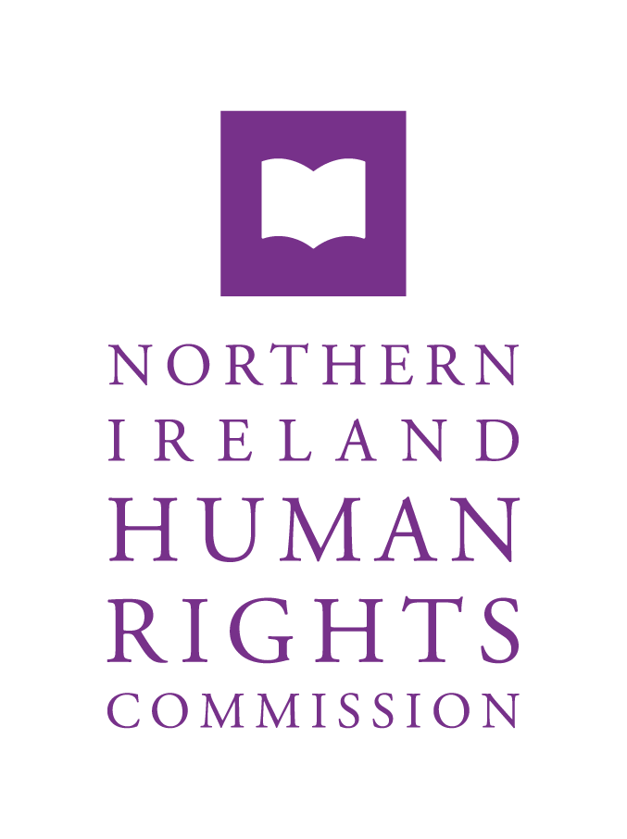

**NIHRC Submission to the Committee for Justice - Protection from Stalking Bill**

**Call for Evidence**

**April 2021**

**Table of Contents**

Summary of Recommendations 3

1.0 Introduction 4

2.0 General Comments 6

3.0 Specific Clauses of the Bill 8

Stalking Prevention Orders 8

Rehabilitation of Offenders 9

4.0 Disagregated Data 10

# Summary of Recommendations

**The NI Human Rights Commission (NIHRC):**

* 1. continues to call on the UK Government to ratify the Istanbul Convention and advises the Department to continue to work with the UK Government on achieving this goal.

2.10 continues to call on the Department to be effectively resourced in order to fully implement the Gillen Report Recommendations.

2.11 recommends the Department consider a public awareness campaign to raise awareness of what constitutes the offence of stalking and the consequences of committing the offence.

2.14 continues to recommend the Department introduces a specific criminal offence of upskirting in Northern Ireland and ensures effective protection of victims or potential victims without further delay.

3.11 recommends the Department consider amending the Bill to clarify that behaviour amounting to stalking offences must be satisfied after the change in legislation for the application for a Stalking Prevention Order. Only then can previous behaviour be considered retrospective of the change in law.

2.15 recommends the Department provide clarity around howrehabilitation of offender legislation will apply to of stalking offenders.

4.3 recommends that the Department works with the relevant public authorities and civil society organisations to systematically collect and publish data on stalking that is disaggregated by sex, gender, ethnicity, disability and age. It should also record the journey of stalking investigations through the criminal justice system, including the number of initial reports, number of referrals to the Public Prosecution Service, how many reach different stages of the court process, how many result in prosecutions, what is the resulting remedy and how many repeat offences occur.

# Introduction

1.1 The Northern Ireland Human Rights Commission (the Commission), pursuant to Section 69(1) the Northern Ireland Act 1998, reviews the adequacy and effectiveness of law and practice relating to the protection of human rights. In accordance with these functions, the following statutory advice is submitted to the Department of Justice in response to its consultation on creating a new offence of stalking in Northern Ireland (NI).

* 1. The Commission bases its advice on the full range of internationally accepted human rights standards, including the European Convention on Human Rights as incorporated by the Human Rights Act 1998 and the treaty obligations of the Council of Europe (CoE), European Union (EU) and United Nations (UN) systems. The relevant international treaties in this context include:
* European Convention on Human Rights 1950 (ECHR);[1]
* International Covenant on Economic, Social and Cultural Rights 1966 (ICESCR);[2]
* International Covenant on Civil and Political Rights 1966 (ICCPR);[3]
* UN Convention on the Elimination of All Forms of Discrimination Against Women 1979 (UN CEDAW);[4]
* European Convention on Compensation for Victims of Violent Crimes 1983;[5]
* UN Convention against Torture 1987 (UN CAT);[6]
* European Convention for the Prevention of Torture and Inhuman or Degrading Treatment or Punishment 1987;[7]
* UN Convention on the Rights of the Child 1989 (UN CRC);[8]
* Charter of Fundamental Rights of the European Union 2000;[9]
* UN Convention on the Rights of Persons with Disabilities 2006 (UN CRPD);[10]
* Council of Europe Convention on Preventing and Combating Violence against Women and Domestic Violence 2011 (Istanbul Convention);[11]
* EU Directive establishing Minimum Standards on the Rights, Support and Protection of Victims of Crime 2012 (EU Victims Directive).[12]
  1. In addition to these treaty standards, there exists a body of ‘soft law’ developed by the human rights bodies of the United Nations (UN) and the Council of Europe (CoE). These declarations and principles are non-binding but provide further guidance in respect of specific areas. The relevant standards in this context include:
* UN Declaration of Basic Principles of Justice for Victims of Crime and Abuse of Power 1985;[13]
* UN Declaration on the Elimination of Violence against Women 1993;[14]
* UN Beijing Declaration and Platform for Action 1995;[15]
* CoE Committee of Ministers Recommendation on the Protection of Women against Violence 2002[16]
* UN Resolutions on the Intensification of Efforts to Eliminate all forms of Violence against Women 2006, 2012;[17]
* UN Report of the Secretary General on the Intensification of Efforts to Eliminate all forms of Violence against Women 2010;[18]
* UN Resolution on Strengthening Crime Prevention and Criminal Justice responses to Violence against Women 2011;[19]
* UN Commission on the Status of Women conclusions of the 57th session 2013;[20]
* UN Committee on the Elimination of All Forms of Discrimination against Women General Recommendation 35, 2017.[21]
  1. The NIHRC has continuously raised concerns that NI is the only jurisdiction within the UK without specific stalking legislation. The Commission therefore welcomes the Prevention from Stalking Bill as standalone legislation prohibiting all forms of stalking in NI.

# General Comments

* 1. The NIHRC has continuously raised the need for legislation to address the prevention of stalking in line with Article 34 Istanbul Convention which states that:

Parties shall take the necessary legislative or other measures to ensure that the intentional conduct of repeatedly engaging in threatening conduct directed at another person, causing her or him to fear for her or his safety, is criminalised.

* 1. The NIHRC would refer the Justice Committee to the Commission’s Submission to Department of Justice Consultation on Creating a New Offence of Stalking in Northern Ireland within which the Commission sets out in detail the relevant human rights standards and oblgiations in regards to the prevention and prohibitation of stalking.[22] This response will therefore not go into the detail of such obligations and instead highlight technical issues within the Bill.
  2. The NIHRC recognises that the Bill as introduced widely adopts recommendations put forward by the Commission within its previous consultation response. The Commission welcomes the introduction of Stalking Prevention Orders and the definition of what constitutes an offence of stalking as non-exhaustive and inclusive. The Commission further welcomes the inclusion of cyber stalking within the scope of the legislation which is a particular growing concern.
  3. The NIHRC recognises the introduction of the Prevention against Stalking

Bill as a step in the right direction towards implementing the

Istanbul Convention.

* 1. **The NIHRC continues to call on the UK Government to ratify the**

**Istanbul Convention and advises the Department to continue to**

**work with the UK Government on achieving this goal.**

* 1. However, the Commission would highlight further steps the Department needs to take in regards to developing legislation relating to violence that disproportionately impacts on women and girls to ensure full compliance with the Istanbul Convention and the UN Convention of Elimination of Discrimination against Women.
  2. Following the introduction of the Bill the Commission would advise that it must be followed by training across the criminal justice system and awareness raising for the wider public.
  3. The NIHRC continues to recommend that the Department implement the recommendations of the Gillen Review. Of particular relevance to the implementation of the Prevention of Stalking Bill would be Recommendation 13 of the Gillen Review states that:

The Judicial Studies Board, the Bar Council and the Law Society should afford a higher priority to training and awareness from outside agencies on such matters as the trauma suffered by victims including children, rape mythology, jury misconceptions and jury guidance. Training should also include topics such as under-reporting and the reasons around withdrawal of complainants from the process of sexual offences, and how best to approach the cross-examination of children and vulnerable witnesses.[23]

* 1. The Commission acknowledges the Minister of Justice’s recent reference to implementing the Gillen Review recommendations in her statement on Civil Justice Modernisation.[24]
  2. **The NIHRC continues to call on the Department to be effectively resourced in order to fully implement the Gillen Report Recommendations.**
  3. **The NIHRC recommends the Department consider a public awareness campaign to raise awareness of what constitutes the offence of stalking and the consequences of committing the offence.**
  4. Article 40 of the Istanbul Convention requires Parties to:

take the necessary legislative or other measures to ensure that any form of unwanted verbal, non-verbal or physical conduct of a sexual nature with the purpose or effect of violating the dignity of a person, in particular when creating an intimidating, hostile, degrading, humiliating or offensive environment, is subject to criminal or other legal sanction.

* 1. In England and Wales, the Voyeurism (Offences) Act 2019, which criminalises upskirting, came into force on 12 April 2019. Similar legislative provision has been made in Scotland through the Sexual Offences (Scotland) Act 2009. There are no similar provisions that currently provide for the specific offence of upskirting in Northern Ireland though it can be dealt with under other legislation which is not bespoke.
  2. **The NIHRC also continues to recommend the Department introduces a specific criminal offence of upskirting in Northern Ireland and ensures effective protection of victims or potential victims without further delay.**

# Specific Clauses of the Bill

* 1. The Commission wishes to highlight a number of technical issues within the Bill that need further consideration to ensure compliance with human rights standards.

## Stalking Prevention Orders

* 1. The Commission would highlight that the Stalking Prevention Orders do not explicitly include provision for the potential use of intermediaries in stalking. Considering stalking is a form of controlling behaviour it may be possible that the perpetrator may procure an individual to carry out offences on their behalf.
  2. The Commission would highlight that The Protection from Harassment (Northern Ireland) Order 1997 extends to third parties in this regard.
  3. **The NIHRC recommends that the Department consider amending the legislation to include provision for third parties carrying out offences on behalf of the perpetrator.**
  4. Section 8 of the Bill concerns the power to make orders and states that it does not matter whether the acts were carried out in a part of the United Kingdom or elsewhere, or whether they were carried out before or after the coming into operation of this section. The Commission is concerned with the inclusion of offences retrospect to the enactment of the legislation.
  5. The NIHRC would highlight that this engages Article 7 ECHR which provides that:

No one shall be held guilty of any criminal offence on account of any act or omission which did not constitute a criminal offence under national law at the time when it was committed. Nor shall a heavier penalty be imposed than the one that was applicable at the time the criminal offence was committed.

* 1. In this regard Article 7 ECHR unconditionally prohibits the retrospective application of the criminal law where it is to an accused’s disadvantage.[25] The principle of non-retroactivity of criminal law applies both to the provisions defining the offence and to those setting the penalties incurred.
  2. The principle of non-retroactivity is infringed in cases of retroactive application of legislative provisions to offences committed before those provisions came into force. Therefore, it is prohibited to extend the scope of offences to acts which previously were not criminal offences.
  3. The NIHRC is concerned that the Bill currently provides that a Stalking Prevention Order can be sought for behaviour before the commencement of legislation even if there is no evidence of it having continued after the change in law.
  4. The Commission would propose that the law must be satisfied after commencement of the legislation to ensure compliance with Article 7 ECHR. However, on meeting this requirement the Commission suggests that consideration of a course of conduct prior to the change in legislationcan then be taken into account..
  5. **The NIHRC recommends the Department consider amending the Bill to clarify that behaviour amounting to stalking offences must be satisfied after the change in legislation for the application for a Stalking Prevention Order. Only then can previous behaviour be considered retrospective of the change in law.**

## Rehabilitation of Offenders

* 1. The Commission is concerned with the lack of clarity regarding the rehabilitation for offenders who have committed stalking offences.
  2. The NIHRC would advise the Department provides whether stalking offences will be classified as a general offence under the Rehabilitation of Offenders (Northern Ireland) Order 1978. As well as whether having a Stalking Prevention Order will be a spent conviction or require disclosure for specific employment.
  3. This would provide clarity on disclosure processes for offenders and employees. If an employer conducts vetting procedures on an employee with a Stalking Prevention Order what detail would be provided and wherean individual has several Orders would this require enhanced vetting procedures to identify.
  4. **The NIHRC recommends the Department provide clarity around howrehabilitation of offender legislation will apply to all stalking offenders.**

# Disagregated Data

* 1. The NIHRC is concerned that currently very little data on stalking exists in Northern Ireland.
  2. The UN CEDAW Committee in its 2019 concluding observations on the UK recommended that the UK Government and NI Executive “systematically collect and publish data, disaggregated by sex, gender, ethnicity, disability and age, throughout the whole of its territory to inform policymaking and assess the impact of measures taken”.[26]
  3. **The NIHRC recommends that the Department works with the relevant public authorities and civil society organisations to systematically collect and publish data on stalking that is disaggregated by sex, gender, ethnicity, disability and age. It should also record the journey of stalking investigations through the criminal justice system, including the number of initial reports, number of referrals to the Public Prosecution Service, how many reach different stages of the court process, how many result in prosecutions, what is the resulting remedy and how many repeat offences occur.**

**Contact us**

**Rhyannon Blyth**

**Director of Legal, Policy and Investigations**

[www.nihrc.org](http://www.nihrc.org) | [info@nihrc.org](mailto:info@nihrc.org) | +44 (0)28 9024 3987

4th Floor, Alfred House, 19-21 Alfred Street, Belfast, BT2 8ED



1. Ratified by the UK in 1951.
2. Ratified by the UK in 1976.
3. Ratified by the UK in 1976.
4. Ratified by the UK in 1981.
5. Ratified by the UK in 1990.
6. Ratified by the UK in 1988.
7. Ratified by the UK in 1988 (as amended by Protocols No. 1 and No.2 1993).
8. Ratified by the UK in 1991.
9. Ratified by the UK in 2000.
10. Ratified by the UK in 2009.
11. Signed by the UK in 2012. The UK has not yet ratified this Convention but has committed to do so with the enactment of the Preventing and Combating Violence against Women and Domestic Violence (Ratification of Convention) Act 2017. The UK Mission at Geneva has also stated, “the UK’s approach to signing international treaties is that we only give our signature where we are fully prepared to follow-up with ratification in a short time thereafter”. *See* UK Mission at Geneva, ‘Universal Periodic Review Mid-term Progress Update by the United Kingdom on its Implementation of Recommendations Agreed in June 2008’ (UKMIS), at recommendation 22 (France).
12. Directive 2012/29/EU of the European Parliament and of the Council of 25 October 2012 establishing minimum standards on the rights, support and protection of victims of crime.
13. A/RES/40/34, ‘UN General Assembly Principles of Justice for Victims of Crime and Abuse of Power,’ 29 November 1985
14. A/RES/48/104, ‘UN General Assembly Declaration on the Elimination of Violence against Women,’ 23 February 1994
15. UN Beijing Declaration and Platform for Action adopted by the UN 4th World Conference on Women, 4-15 September 1995.
16. Recommendation Rec(2002)5 of the Committee of Ministers to Member States on the protection of women against violence, 30 April 2002
17. A/RES/61/143, ‘UN General Assembly Resolution on Intensification of efforts to eliminate all forms of violence against women,’ 30 January 2007; A/RES/67/144, ‘UN General Assembly Resolution on Intensification of efforts to eliminate all forms of violence against women,’ 20 December 2012
18. A/RES/65/208, ‘UN General Assembly Resolution on Extrajudicial, Summary or Arbitrary Executions,’ 21 December 2010.
19. A/RES/65/228, ‘UN General Assembly Resolution on strengthening crime prevention and criminal justice responses to violence against women,’ 21 December 2010.
20. E/2013/27, ‘Commission on the Status of Women report on the fifty-seventh session’, 4 – 15 March 2013
21. CEDAW/C/GC/35, ‘UN Committee on the Elimination of Discrimination against Women, General recommendation No.35 on gender-based violence against women’, 14 July 2017.
22. NI Human Rights Commission, ‘Submission to DOJ’s Consultation on Creating a New Offence of Stalking in Northern Ireland’, 25 February 2019.
23. John Gillen, ‘Gillen Review Report into the Law and Procedures in Serious Sexual Offences in Northern Ireland Recommendations’ (DoJ, 2019).
24. NI Assembly Hansard, ‘Ministerial Statement: Civil Justice Modernisation – Minister for Justice Niaomi Long MLA’, 23 March 2021.
25. *Del Rio Prada v Spain* (2013) ECHR 1004; *Kokkinakis v Greece* (1993) ECHR 397.
26. CEDAW/C/GBR/CO/8, ‘UN CEDAW Committee Concluding Observations on the Eighth Periodic Report of the UK of Great Britain and NI’, 14 March 2019, at para 26(d).