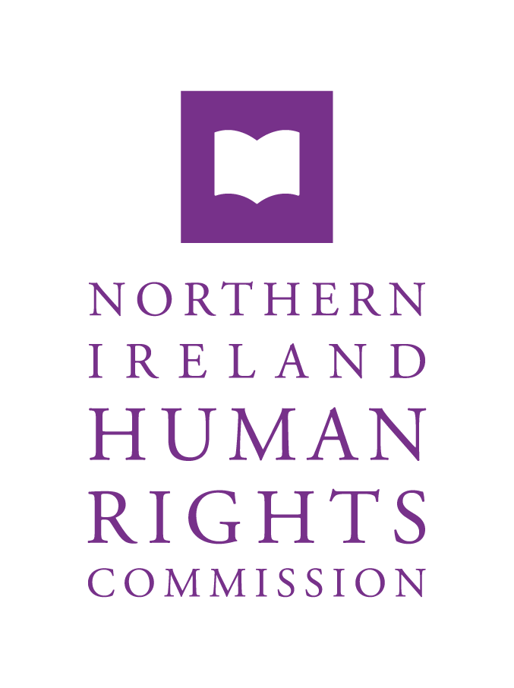

INVESTIGATION: SEXUAL AND REPRODUCTIVE HEALTH EDUCATION IN NORTHERN IRELAND

TERMS OF REFERENCE

MARCH 2022

Introduction

The Northern Ireland Human Rights Commission (the Commission) has decided to conduct an investigation into the provision of education on sexual and reproductive health in Northern Ireland (the Investigation). The Investigation is pursuant to Section 69(8) of the Northern Ireland Act 1998, under which the Commission may carry out such investigations as it considers necessary or expedient in fulfilling its statutory functions.

The Commission aims to conclude its investigation by 31 March 2023.

Reasons for Investigation

The Investigation will consider and establish the extent to which the Department of Education and other relevant public authorities are acting consistently with the recommendation of the UN Committee on the Elimination of Discrimination against Women to make “age-appropriate, comprehensive and scientifically accurate education on sexual and reproductive health a compulsory component of curriculum for adolescents covering prevention of early pregnancy and access to abortion” in Northern Ireland.

That recommendation was given effect in domestic legislation by Section 9 of the Northern Ireland (Executive Formation etc.) Act 2019. Section 9 requires the Secretary of State for Northern Ireland to ensure implementation of the relevant recommendation contained at sub-paragraph 86(d) of the UN CEDAW Committee’s report, following its inquiry into abortion services in Northern Ireland.
Paragraph 86 (d) requires the State Party (the UK government and the NI Executive) to “Make age-appropriate, comprehensive and scientifically accurate education on sexual and reproductive health and rights a compulsory component of curriculum for adolescents, covering prevention of early pregnancy and access to abortion, and monitor its implementation.”

Methodology

The Investigation will:

  - Identify the legal, policy and regulatory framework in Northern Ireland for the provision of sexual and reproductive health education in schools;
  - Identify the extent to which the human rights of children and young people to access age appropriate, comprehensive and scientifically accurate sexual and reproductive education are realised in law, policy and practice;
  - Identify good practice and make recommendations where necessary for improvement;
  - Increase public awareness of human rights generally and in the specific context of children’s health education.

Such an investigation relies upon engagement with and cooperation of those involved in the provision of education, which includes relevant government departments, public authorities, third sector organisations, post primary schools, teaching unions, civil society organisations and churches.

The Commission will engage with relevant stakeholders through meetings and/or roundtable events.

The Commission will utilise its investigatory powers to obtain relevant information and documentation from the Department of Education, public bodies responsible for curriculum development and delivery; all post primary schools in NI and, relevant third sector or private contractors involved in the provision of education on sexual and reproductive health in schools.

The Commission has commissioned independent external research, by experts with specialist experience and expertise, to assist in conducting an analysis of the current provision of sexual and reproductive health education in NI schools.

The Commission shall publish a report on its findings, as required by Section 69(8) of the Northern Ireland Act 1998 at the conclusion of the investigation. In that report, it is envisaged that the Commission will make conclusions and any recommendations for action considered necessary for the promotion and protection of human rights. The report will be presented to the Northern Ireland Executive and Legislative Assembly.

Background

The United Nations Convention on the Rights of Children (UN CRC) requires the State to provide access to sexual and reproductive health information. States should ensure that “meaningful sexual and reproductive health education is part of the mandatory school curriculum for all schools, including academies, special schools and youth detention centres”. Such information should include family planning and contraceptives, the dangers of early pregnancy, the prevention of HIV/AIDS, the prevention and treatment of sexually transmitted diseases (STDs). Education should be age-appropriate and include “confidential sexual and reproductive health-care services; contraceptives; the prevention of sexual abuse or exploitation, including sexual bullying; the support available in cases of such abuse and exploitation; and sexuality, including that of lesbian, gay, bisexual, transgender and intersex children”.

The right to sexual and reproductive health (as an integral element of the right to health), when combined with the right to education (Articles 13 and 14 UNCRC) and the right to non-discrimination and equality between men and women (Articles 2(2) and 3 UNCRC), means there is a right to education on sexuality and reproduction that is comprehensive, non-discriminatory, evidence-based, scientifically accurate and age appropriate. Furthermore, it recognises that “preventing unintended pregnancies and unsafe abortions requires States to adopt legal and policy measures to guarantee all individuals access to affordable, safe and effective contraceptives and comprehensive sexuality education, including for adolescents”.

The International Covenant on Economic, Social and Cultural Rights (ICESR) recognises that a minimum core obligation on States is to ensure access “to comprehensive education and information on sexual and reproductive health that are non-discriminatory, non-biased, evidence-based, and that take into account the evolving capacities of children and adolescents”.
In line with the right of the child to be heard, when developing policy, States should “establish structures for the active and meaningful participation of children and give due weight to their views in designing laws, policies, programmes and services at the local and national levels” in respect of issues including sexual and reproductive education and giving consideration to “involving younger children and children in vulnerable situations, such as children with disabilities.

States must also take effective and appropriate measures to eliminate discrimination against persons with disabilities in all matters relating to marriage, family, parenthood and relationships, on an equal basis with others, so as to ensure that persons with disabilities, including access to age-appropriate information, reproductive and family planning education. The CRPD Committee has confirmed that, on an equal basis with others, persons with disabilities “must be provided with age-appropriate, comprehensive and inclusive sexuality education, based on scientific evidence and human rights standards, and in accessible formats”.

Currently, the NI curriculum does not, for any key stage, refer to sexual or reproductive health education. Instead, its focus is “personal development and mutual understanding” for key stages 1 and 2 (primary school children) and “learning for life and work” in key stages 3 & 4, which includes “personal development”. Guidance has been introduced and a ‘relationship and sexuality hub’ has been developed, to provide resources for topics such as: consent; contraception; domestic violence and abuse; LGBTQ+ issues; special educational needs; and, social media. However, decisions about whether and how to make provision falls to individual schools.

Focusing specifically on the UK, the UN CRC has observed that the rate of teenage pregnancy is higher than the average in the EU, in particular in deprived areas. The UN CEDAW Committee has highlighted that “NI youth are denied the education necessary to enjoy their sexual and reproductive health and rights” and “that access to abortion services and contraceptives are not statutory requirements of the advisory curriculum”. The Committee found that the State had failed to prioritise the prevention of unplanned pregnancy through the provision of quality sexuality education. Its lack of oversight on schools’ discretion to deliver the RSE curriculum to ensure that it is evidence based and includes contraceptive use, safe abortion and post-abortion care was found to violate article 10(h) of CEDAW.

Moreover, Sir John Gillen made specific reference to the need for comprehensive relationship and sexual education in his report following the Gillen Review. He recognised the role such education this plays in the prevention of sexual offences as well as in achieving justice in trials that take place. He further recommended the Department for Education should “address the need to include in the school curriculum for disabled children, children with sensory disability and those who are members of marginalised communities’ sex education designed in a culturally sensitive manner on matters such as consent, personal space, boundaries, appropriate behaviour, relationships, fears of homophobia and transphobia, gender identity and sexuality.”

The UN CRC Committee has also raised concerns at the lack of mandatory training on relationships and sexuality and the variance in quality, where it is provided. It highlights that lesbian, gay, bisexual, transgender and intersex children do not have access to accurate information on their own sexuality or gender identity.

In its 2021 List of Issues Prior to Reporting, the Committee requested further information from the UK Government in respect of teenage pregnancy and explain measures taken to “ensure that mandatory sexual and reproductive health education includes material on sexual orientation and gender identity”. The UN CRC has also highlighted the importance of finding “proper means and methods of providing information that is adequate and sensitive to the particularities and specific rights of adolescent girls and boys”.

The UN CRC Committee noted that bullying remains a serious and widespread problem particularly against a number of vulnerable groups including LGBTQI+ children and children with disabilities. It also notes the lack of capacity of students and staff members to respect diversity at school.

The Expert Panel Reports, supporting the development of the social inclusion strategies including both the Gender Equality Strategy and LGBTQI+ Strategy, have both made recommendations that inclusive relationships and sexuality education should be taught in a comprehensive and standardised way across all schools and that should not be dependent on school ethos.

CEDAW/C/OP.8/GBR/1, ‘UN CEDAW Committee Inquiry Concerning the United Kingdom of Great Britain and Northern Ireland under Article 8 of the Optional Protocol to the UN CEDAW Report of the Committee’, 6 March 2018, at para 86(d).
CRC/GC/2003/41, ‘UN Committee on the Rights of the Child General Comment No.4: Adolescent health and development in the context of the Convention on the Rights of the Child, July 2003 at para 24.
CRC/C/GBR/CO/5, ‘Committee on the Rights of the Child Concluding observations on the fifth periodic report of the United Kingdom of Great Britain and Northern Ireland’, 12 July 2016 at para 65(b).
CRC/GC/2003/41, ‘UN Committee on the Rights of the Child General Comment No.4: Adolescent health and development in the context of the Convention on the Rights of the Child, July 2003 at paras 24, 27.
CRC/C/GBR/CO/5, ‘Committee on the Rights of the Child Concluding observations on the fifth periodic report of the United Kingdom of Great Britain and Northern Ireland’, 12 July 2016 at para 65(b).
CESCR, Article 12.
E/C.12/GC/22, ‘UN Committee on Economic, Social and Cultural Rights General Comment No.22 on the right to sexual and reproductive health (article 12 of the International Covenant on Economic, Social and Cultural Rights) 2 May 2016 at paras 9, 47.
E/C.12/GC/22, ‘UN Committee on Economic, Social and Cultural Rights General Comment No.22 on the right to sexual and reproductive health (article 12 of the International Covenant on Economic, Social and Cultural Rights) 2 May 2016 at para 28.
E/C.12/GC/22, ‘UN Committee on Economic, Social and Cultural Rights General Comment No.22 on the right to sexual and reproductive health (article 12 of the International Covenant on Economic, Social and Cultural Rights) 2 May 2016 at para 49(f).
CRC/C/GBR/CO/5, ‘Committee on the Rights of the Child Concluding observations on the fifth periodic report of the United Kingdom of Great Britain and Northern Ireland’, 12 July 2016 at para 31(a).
UNCRPD, Article 23(1)(b)
CRPD/C/GC/4, ‘UN CRPD Committee General Comment No. 4 (2016) on the right to inclusive education’, 26 November 2016 at para 54.
The Education (Curriculum Minimum Content) Order (NI) 2007 – Schedule 2 part 1
CRC/C/GBR/CO/5, ‘Committee on the Rights of the Child Concluding observations on the fifth periodic report of the United Kingdom of Great Britain and Northern Ireland’, 12 July 2016 at para 64(a).
CEDAW/C/OP.8/GBR/1, ‘UN CEDAW Committee Inquiry Concerning the United Kingdom of Great Britain and Northern Ireland under Article 8 of the Optional Protocol to the UN CEDAW Report of the Committee’, 6 March 2018, at para 43.
CEDAW/C/OP.8/GBR/1, ‘UN CEDAW Committee Inquiry Concerning the United Kingdom of Great Britain and Northern Ireland under Article 8 of the Optional Protocol to the UN CEDAW Report of the Committee’, 6 March 2018, at para 44.
CEDAW/C/OP.8/GBR/1, ‘UN CEDAW Committee Inquiry Concerning the United Kingdom of Great Britain and Northern Ireland under Article 8 of the Optional Protocol to the UN CEDAW Report of the Committee’, 6 March 2018, at para 76.
Sir John Gillen, ‘Report into the law and procedures in serious sexual offences in Northern Ireland- Recommendations’ (DoJ, 2019), at recommendation 4, p.1.
Sir John Gillen, ‘Report into the law and procedures in serious sexual offences in Northern Ireland- Recommendations’ (DoJ, 2019), at p.450, para 181.
CRC/C/GBR/CO/5, ‘Committee on the Rights of the Child Concluding observations on the fifth periodic report of the United Kingdom of Great Britain and Northern Ireland’, 12 July 2016 at para 64(b).
Ibid.
CRC/C/GBR/QPR/6-7, ‘UN Committee on the Rights of the Child, List of issues prior to submission of the combined sixth and seventh reports of the United Kingdom of Great Britain and Northern Ireland’, 4 March 2021 at para 29(e).
CRC/GC/2003/41, ‘UN Committee on the Rights of the Child General Comment No.4: Adolescent health and development in the context of the Convention on the Rights of the Child, July 2003 at para 24.
CRC/C/GBR/CO/5, ‘Committee on the Rights of the Child Concluding observations on the fifth periodic report of the United Kingdom of Great Britain and Northern Ireland’, 12 July 2016 at para 48(a).
Ibid, at para 49(a).
Department for Communities, 'Gender Equality Strategy Expert Advisory Panel Report', (DfC, 2021) and Department for Communities, ' LGBTQI+ Strategy Expert Advisory Panel – Themes and Recommendations, (DfC, 2021).

